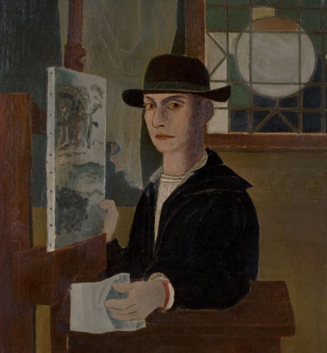
🎨 Roy Lichtenstein – Pop Art Superstar!

🖌️ What did Roy Lichtenstein create?
Roy Lichtenstein was a famous artist who made bold, colourful pictures inspired by comic books and advertisements. His artwork often looks like it came right from the pages of a comic strip! He used bright colours, thick outlines, Ben-Day dots (tiny dots that blend into colours), and speech bubbles.

👶 4 Things About His Childhood
• Roy was born on October 27, 1923 in New York City, USA.
• He loved drawing superheroes and cartoons as a child.
• He liked going to jazz concerts and often sketched the musicians.
• His mother was a piano player and encouraged his creativity.

🧑‍🎨 4 Things About His Art Education
• Roy studied at the Art Students League of New York when he was just a teenager.
• He went to Ohio State University, where he studied fine art.
• He had to pause his studies to fight in World War II.
• After the war, he returned to university and later became an art teacher.

🧑‍💼 4 Things About His Career
• In the 1960s, Roy became famous for his Pop Art style.
• People were amazed (and shocked!) that he turned comic panels into fine art.
• His work challenged what people thought "real art" could be.
• He became one of the most important Pop Artists in the world, alongside Andy Warhol.

🖼️ 4 Famous Artworks by Roy Lichtenstein
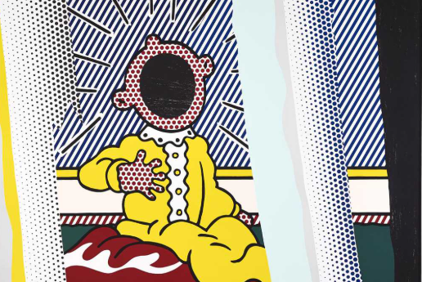
Reflections on a screen

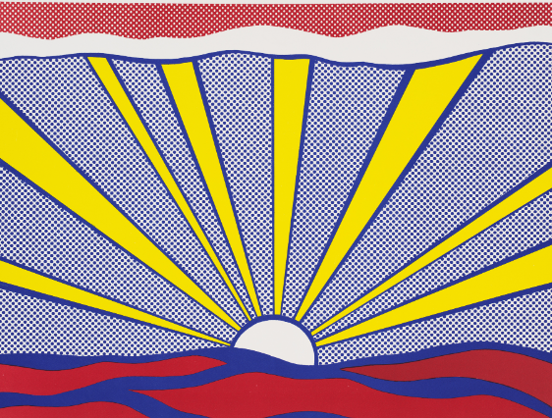
Sunrise

Explosion

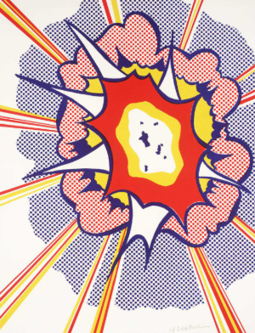

💬 Quotes from Roy Lichtenstein
“Art doesn’t have to be serious.”
“I want my painting to look as if it had been programmed.”
“Pop Art looks out into the world. It doesn’t look like a painting of something, it looks like the thing itself.”

