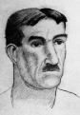
👤 Who Was Joseph Fernand Henri Léger?
He was a French painter, sculptor, and filmmaker.
He painted cities, machines, and people using bold shapes and bright colours.
He believed art should be for everyone to enjoy!

👦 His Childhood
- Léger was born in France in 1881, in a town called Argentan.
- He grew up on a farm and liked watching people work with tools and machines.
- As a child, he didn’t paint much—he wanted to be an architect!

🎓 His Education
- Henri studied technical drawing and trained to be an architect.
- He moved to Paris in 1900 to study art.
- He learned at art schools like the École des Arts Décoratifs and the Académie Julian.
- Soon, he created his own modern style using shapes and colour!

🎨 What Kind of Art Did He Make?
- He used circles, squares, lines, and bright colours.
- His art looked like robots, buildings, and workers.
- He was part of the Cubist movement—a style that breaks things into shapes

🧠 Fun Facts
- He was a soldier in World War 1. The war made him see people and machines differently.
- He made murals, films, and ceramic art too!
- He liked teaching and wanted art to be fun and modern.

🖼️ Famous Artworks by Léger
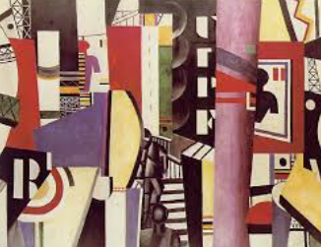
Here are some of the amazing pictures he made:
The City (1919) – A busy painting full of buildings, lights, and movement.

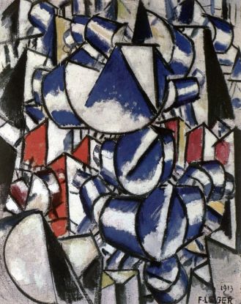
Contrast of Forms (1913) – Just shapes and colours—super modern!

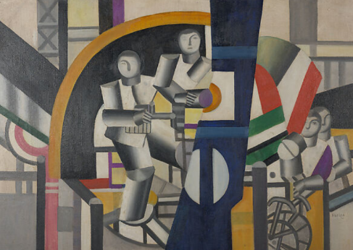
The Builders (1950) – Strong workers building something big.

