Stan Lee
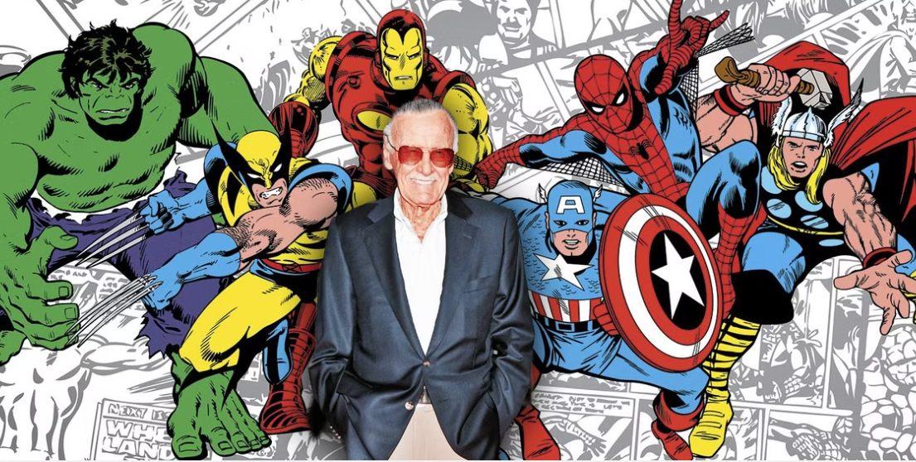https://screenrant.com/marvel-honor-stan-lee-tribute-birthday/

👦 Childhood:
- Stan Lee was born as Stanley Martin Lieber on December 28, 1922, in New York City, USA.
- He grew up in a small apartment in Manhattan with his younger brother, Larry.
- As a child, Stan loved reading books and watching movies, which sparked his interest in storytelling.
- He dreamed of writing the 'Great American Novel' one day.

🎓 Education:
- Stan attended DeWitt Clinton High School in the Bronx, New York.
- He enjoyed writing for the school newspaper and even wrote obituaries for a local news service.
- He graduated high school early, at the age of 16, eager to start his career.

🎨 Career:
- Stan took odd jobs, including writing press releases for the National Tuberculosis Center.
- Stan Lee started working at Timely Comics (which later became Marvel Comics) in 1939 as an office assistant.
- He co-created some of the most famous superheroes, including Spider-Man, the X-Men, Iron Man, Thor, the Hulk, and the Fantastic Four.
- Stan was known for making superheroes with real-life problems, making them more relatable.
- He became the public face of Marvel, appearing in many Marvel movie cameos.

🖼️ Famous Creations:
- Spider-Man 🕷️ – A young superhero with the powers of a spider.
- The Incredible Hulk 💪 – A scientist who turns into a powerful green giant when angry.
- Iron Man 🤖 – A billionaire inventor with a powerful, high-tech suit of armor.
- The X-Men 🧬 – A team of mutant superheroes with extraordinary abilities.

💬 Famous Quotes:
- “With great power comes great responsibility.” – Spider-Man
- “Excelsior!” – Stan Lee’s personal catchphrase, meaning 'ever upward'.
- “I used to be embarrassed because I was just a comic book writer while other people were building bridges or going on to medical careers. And then I began to realise, entertainment is one of the most important things in people’s lives.”
- “The only advice anybody can give is if you want to be a writer, keep writing. And read everything you can.”

