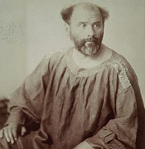
Gustav Klimt

🖌️ What did Gustav Klimt create?
Gustav Klimt was a painter from Austria who loved to use gold, patterns, and beautiful shapes in his art. He painted portraits, nature, and magical scenes, often with sparkly gold and swirling designs. His work is very decorative and unique!

👶 Childhood
- Gustav was born in 1862 in Baumgarten, near Vienna, Austria.
- His dad was a gold engraver, which inspired Klimt’s love for gold in art.
- He had six brothers and sisters!
- His family didn’t have much money, but they all enjoyed art.

🎓 Education
- At age 14, Gustav got a scholarship to the Vienna School of Arts and Crafts.
- He learned how to paint and draw very realistically.
- He studied architecture, fashion, and murals.
- He admired classical art, but later developed his own special style.

🧑‍🎨 Career
- Gustav started by painting walls and ceilings in big buildings.
- He co-founded a group called the Vienna Secession, which celebrated new and modern art.
- His painting style became very decorative and full of patterns.
- Some people loved his art, while others found it strange or shocking.

🖼️ Artworks
The Kiss 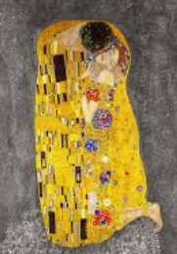
Portrait of Adele Bloch-Bauer 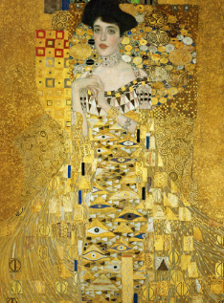
Tree of Life 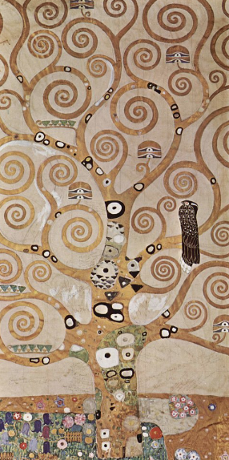
Farm Garden with Sunflowers 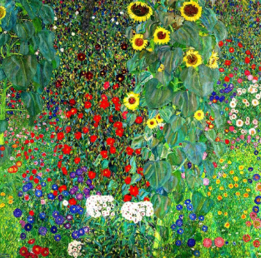

🗣️ Quotes by Gustav Klimt:
- "Art is a line around your thoughts."
- "Whoever wants to know something about me – as an artist, the only thing that’s important – they should look at my pictures."

