🎨 We’ll use shapes and colours like Paul Klee to make a magical city!

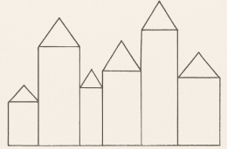
Step 1: Draw Simple Shapes
Use a pencil to draw squares, rectangles, and triangles. These will be your buildings and rooftops.

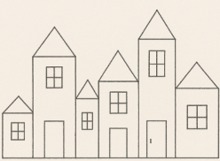
Step 2: Add Windows and Doors
Use smaller squares and rectangles inside your buildings to make windows and doors.

Step 3: Outline in Black
Go over all your lines with a black marker or pen to make them stand out, just like Paul Klee did.

Step 4: Colour in Blocks
Colour each shape with different colours. Try using soft, dreamy colours — or go bold with bright ones! Watercolours or crayons work well.

Step 5: Add Details
Add symbols, stars, or moons in the sky, just like Klee sometimes did.

🧠 Extra Art Ideas Inspired by Paul Klee
- 🏠 Make a shape collage using coloured paper
- 🐱 Draw an imaginary animal using lines and patterns
- 🌜 Make a dreamscape using soft watercolours and symbols

