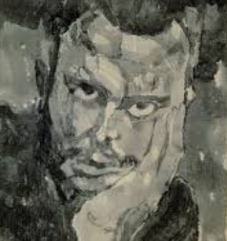
Paul Klee

🖌️ What did Paul Klee create?
Paul Klee was an artist who loved colour, shapes, and imagination. His artwork often looks like dreams, music, or puzzles. He painted animals, people, cities, and symbols, but he didn't try to make them look realistic. Instead, he painted how they felt or how he imagined them.

👶 Childhood
- Paul Klee was born in Switzerland in 1879.
- His mother was Swiss and his father was German — both were musicians.
- He loved to draw in the margins of his schoolbooks.
- As a child, he played the violin and was very talented at music too!

🎓 Education
- Paul Klee went to the Academy of Fine Arts in Munich to study art.
- He learned how to draw in black and white before exploring colour.
- He studied classical art, but didn’t enjoy copying real things.
- He travelled to Italy and Tunisia, where he was inspired by light and colour.

🎨 Career
- He taught at the famous Bauhaus School, where artists explored modern design.
- Klee created over 9,000 artworks in his life — he worked nearly every day!
- His style mixed childlike drawings, abstract shapes, and symbols.
- He also loved to write about art and explain his ideas to students.

💬 Quotes from Paul Klee
- "A line is a dot that went for a walk."
- "Art does not reproduce what we see. It makes us see."
- "Colour and I are one. I am a painter."

🎨 Art
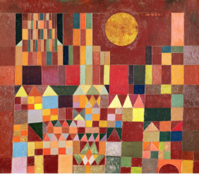
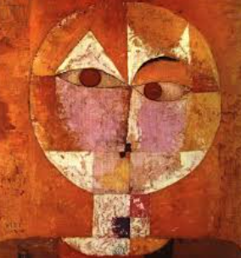
Self portrait

Sailing boats Castle and Sun
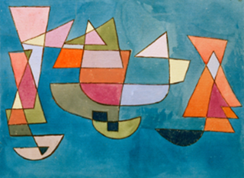
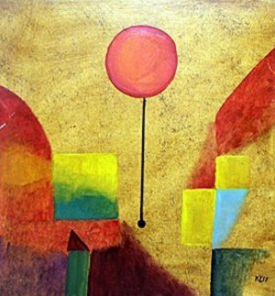

Red Balloon

