Wassily Kandinsky
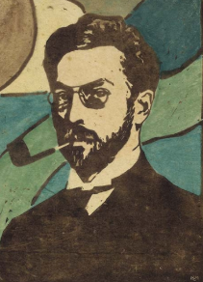

🖌️ What Did Kandinsky Create?
Kandinsky was one of the first artists to paint abstract art—pictures that don’t look like real things but instead use shapes, lines, and colours to express feelings. He believed that colours and shapes could make music for the eyes!

👶 Childhood
- Kandinsky was born in Russia in 1866.
- As a child, he loved bright colours and patterns.
- Kandinsky had synaesthesia, which made him see music as pictures. He played the cello and piano, which helped inspire his later art.
- His family moved often, and he grew up surrounded by different cultures.

🎓 Education
- He first studied law and economics at university in Moscow.
- He became a university professor before becoming an artist.
- At age 30, he went to art school in Munich, Germany.
- He also studied colour theory and was interested in how colours affect emotions.

🎨 Career
- Kandinsky co-founded the art group Der Blaue Reiter ("The Blue Rider").
- He taught at the Bauhaus School, a famous modern art and design school in Germany.
- He believed painting should be like music—abstract and emotional.
- He is known as the father of abstract art.

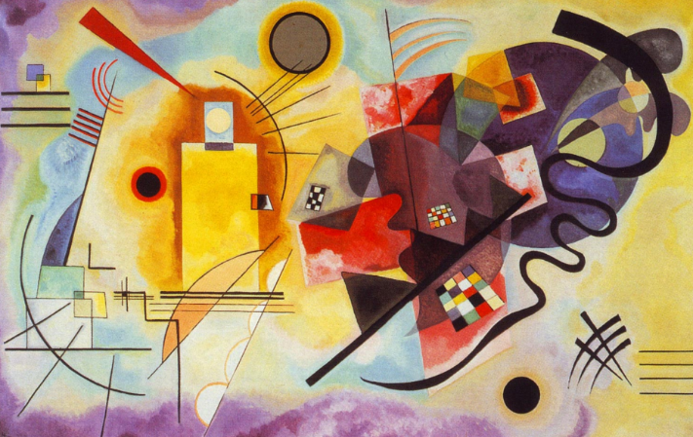
🖼️ Artworks
Yellow-Red-Blue

Improvisation 28
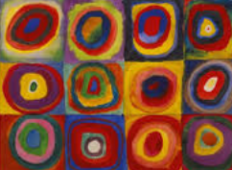
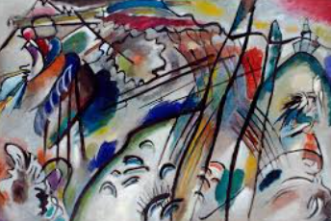
Colour Study: Squares and Circles

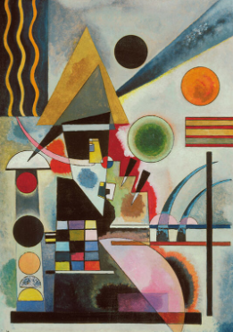
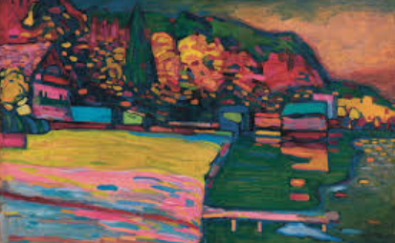
Lake Starnberg
Swinging

💬 Quotes from Kandinsky
- “Colour is a power which directly influences the soul.”
- “The artist must train not only his eye but also his soul.”
- “Everything starts from a dot.”

