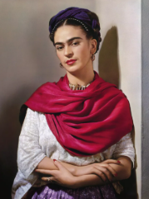
Frida Kahlo
🎨 What They Created
Frida Kahlo is known for her deeply personal and symbolic paintings, often exploring themes of identity, pain, love, and Mexican culture. She painted self-portraits and vibrant artworks filled with symbolism and surreal elements.

👶Childhood
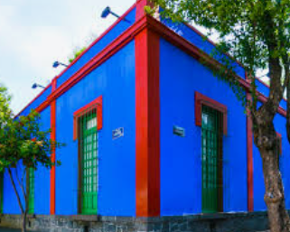
- Frida Kahlo was born on July 6, 1907, in Coyoacán, Mexico City, in her family home known as La Casa Azul (The Blue House).
- She contracted polio at age 6, which left her right leg thinner and weaker than her left, giving her a lifelong limp.
- As a child, Frida enjoyed playing sports, which was unusual for girls at the time. She loved swimming, boxing, and wrestling.
- Frida often joined her photographer father, Guillermo Kahlo, on his work trips, where she developed a keen eye for detail and a love for Mexican culture.

🎓 Education
- Frida attended the prestigious National Preparatory School in Mexico City, where she was one of only 35 girls among 2,000 students.
- She planned to become a doctor and studied medicine before a severe bus accident changed the course of her life.
- Frida learned painting while bedridden, using a special easel her mother built for her, allowing her to paint while lying flat.
- She developed her distinctive style by studying classical European painters and Mexican folk art.

🖼️ Artwork They Created
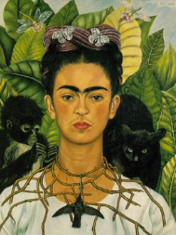
Self-Portrait with Thorn Necklace and Hummingbird

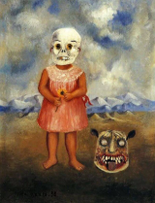

Girl with Death Mask

Self-portrait with monkey
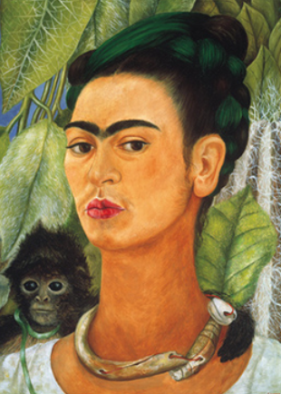
Viva la Vida, Watermelons

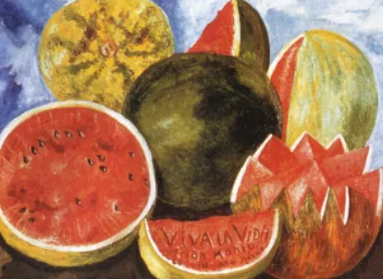

💼 Career
- Frida's first solo exhibition took place in New York at the Julien Levy Gallery in 1938.
- She became an iconic figure in the Surrealist movement, although she famously rejected being labelled as a surrealist.
- Frida taught at La Esmeralda, a prestigious art school in Mexico City, inspiring many young Mexican artists.
- In 1953, she held her first and only solo exhibition in Mexico, attending the opening in a four-poster bed due to her declining health.

💬 Quotes from the Artist
- “I am my own muse. I am the subject I know best. The subject I want to know better.”
- “Feet, what do I need you for when I have wings to fly?”
- “I paint myself because I am so often alone and because I am the subject I know best.”
- “At the end of the day, we can endure much more than we think we can.”

