David Hockney
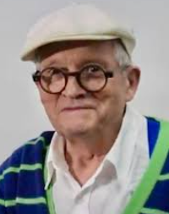
David Hockney is a British artist known for his colourful paintings, drawings, printmaking, photography, and stage designs.
He is one of the most influential contemporary artists, often inspired by landscapes, portraits, and modern life.
He is particularly famous for his vibrant depictions of swimming pools and bright Californian landscapes.

🧒 Childhood
- David Hockney was born on July 9, 1937, in Bradford, England.
- He grew up in a creative and supportive family, where his father encouraged his artistic talents.
- As a child, he loved drawing and often painted in his spare time.
- Hockney showed a strong interest in art from a young age and dreamed of becoming an artist.

🎓 Education
- Hockney attended Bradford Grammar School, where he excelled in art.
- He later studied at Bradford College of Art, where he honed his skills.
- In 1959, he attended the Royal College of Art in London, one of the most prestigious art schools in the world.
- He became known for his unique style, blending realism and abstract elements.

💼 Career
- Hockney moved to Los Angeles in the 1960s, where he created some of his most iconic works.
- He experimented with photography, creating 'joiners' – collage-like photo compositions.
- Hockney has also worked as a stage designer for ballet, opera, and theatre productions.
- His work has been exhibited in major galleries worldwide, and he is considered one of the most influential British artists of the 20th century.

🗣️ Quotes from the Artist:
- "Art has to move you and design does not, unless it's a good design for a bus."
- "I draw, therefore I am."
- "You must plan to be spontaneous."
- "I am always learning."

🖼️ Artwork
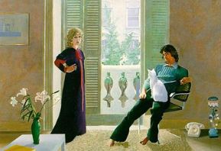
A Bigger Splash
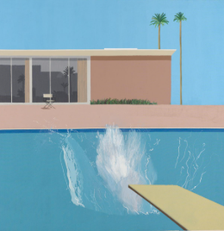
Mr. and Mrs. Clark and Percy

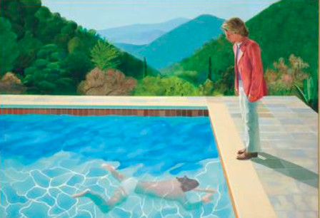
Portrait of an Artist
Garrowby Hill
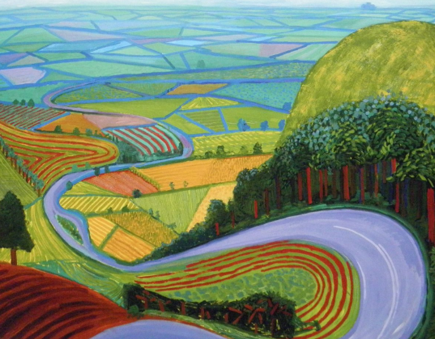

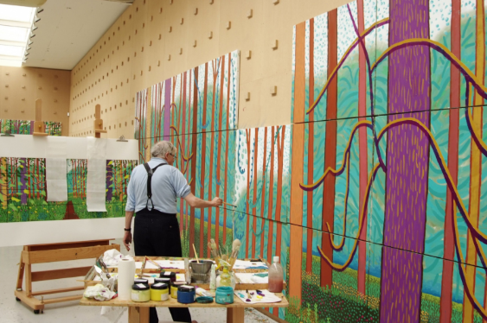

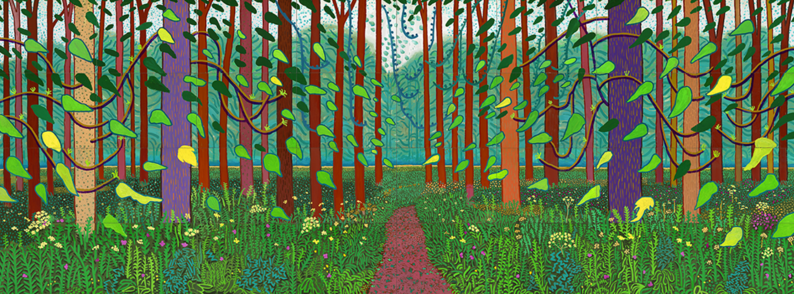
The Arrival of Spring in Woldgate (a series)

