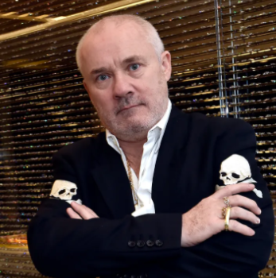
🎨 Damien Hirst

🧪 What does Damien Hirst create?
Damien Hirst is a British artist who is famous for making surprising and thought-provoking art. He uses real animals, medicine, butterflies, dots, and sparkly objects in his work. His art often explores life, death, and science.

👶 Childhood
- Damien Hirst was born in Bristol, England, in 1965.
- He grew up in Leeds, a city in the north of England.
- He loved drawing scary things like monsters and skeletons.
- He often got into trouble at school but was very creative.

🎓 Education
- He studied art at Leeds College of Art.
- He went to Goldsmiths College in London in the 1980s.
- At Goldsmiths, he helped start a new movement called Young British Artists
- He once curated a famous student art show called "Freeze", where he and his friends showed their work.

💼 Career
- Damien became famous in the 1990s with art that used real animals in glass tanks.
- He was supported by collector Charles Saatchi, who helped make him well known.
- He won the Turner Prize in 1995.
- His artwork has sold for millions of pounds around the world.

💬 Quotes from Damien Hirst
- “Art’s about life and it can’t really be about anything else.”
- “Great art is clear thinking about mixed feelings.”
- “I can’t wait to get into a studio and paint.”
- “I always think it’s important to be excited about something.”

🖼️ Artworks
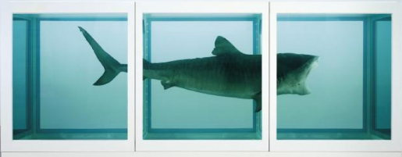
The Physical Impossibility of Death in the Mind of Someone Living
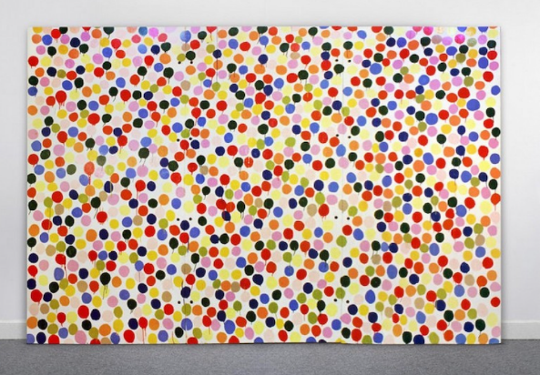

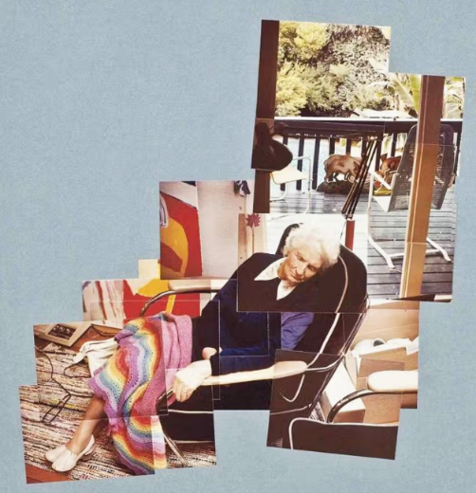
Spot Paintings
Joiner photographs

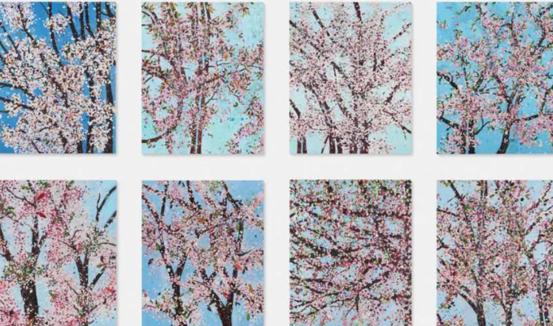

The void

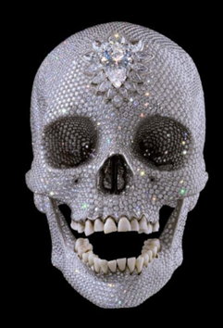
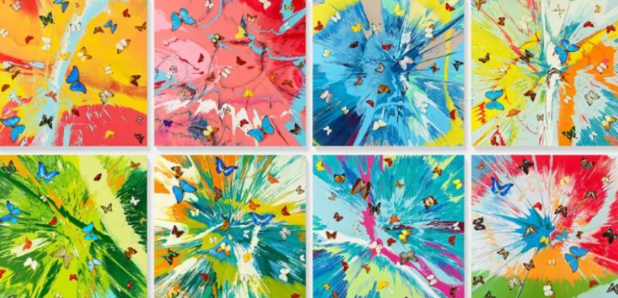
For the Love of God 💎

Butterfly Paintings – real butterfly wings arranged in patterns

