Who was Charley Harper?
Charley Harper was an American artist who loved to draw animals, birds, and nature. He made his pictures very simple but also very clever. He used shapes, colours, and patterns to show what something looked like and how it felt—without lots of tiny details.

🐦 What is the Charley Harper Style?
Charley Harper’s art is:
- Simple – he used basic shapes like circles, triangles, and lines.
- Bright – he loved to use bold, cheerful colours.
- Flat – no shadows or shading, just clear, clean shapes.
- Nature-based – birds, bugs, fish, and flowers were his favourite!
He called his style “minimal realism” – that means he showed the most important parts of something, not every little bit.

🌿 Tips to Be Like Charley Harper:
- Start simple—less is more!
- Use big shapes and bold colours.
- Think about how your animal feels, not just how it looks.
- Keep your picture tidy and balanced.
- Look at nature—then imagine it as shapes!

🎨 What You’ll Need:
- Paper
- Pencil and rubber
- Colouring pencils, markers, or paints
- Ruler or stencils (to help with shapes!)
- Imagination!

Step 1: Pick an Animal or Plant
Choose anything you want, a machine, a house, or something from nature. Look at pictures for ideas.

Step 2: Break your item into Shapes
Ask yourself:
- Is the main part of the item a circle, oval, or rectangle?
- What shapes can you put together to create this item?
- Are there parts such as wings leaves you can make from triangles or lines?
Use your pencil to sketch your item using just simple shapes.

Step 3: Keep It Neat and Flat
No scribbles, shading, or fur—Charley Harper made everything smooth and tidy. Go over your shapes with pen or a dark pencil once you're happy.

Step 4: Add Bright Colours
Use colours that make your creature stand out!
Try:
- Red animals
- Green leaves
- Blue water
- Orange houses
Use block colour – fill each shape with one solid colour.

Step 5: Add Patterns and Lines
Charley Harper liked to include:
- Lines on wings
- Dots on bugs
- Stripes on fish
Add little patterns that help people recognise the item.

More fun ideas
🐞Cut out paper shapes and use them to make a bug or a fish collage
- Body: oval
- Head: circle
- Antennae: thin long rectangles
- Legs: thin rectangles

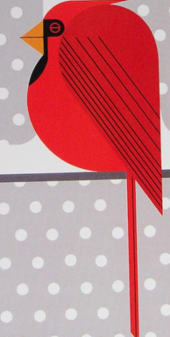
✏️ Illustrate Your Own Charley Harper bird!
- Think about a bird
- What is the basic shape of your bird? Is it large, thin, pointy, tall, small?
- If you broke your birds body type into basic shapes what would they be?
- Draw those basic shapes: an oval body, a triangle wing, a little round head?
- Does it have any prominent features? A large tail, round body, pointy head? What shape would they be? Add them
- Is it famous for anything? For example: robins have large red tummies, peacocks have long flowing tales, owls have large round eyes, accentuate these features.
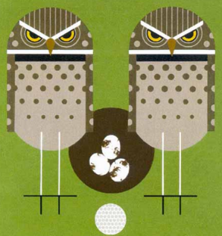
- What is the birds personality? Is it grumpy, angry, clever?
How will you show that? frown lines? grumpy eyebrows? evil eyes?
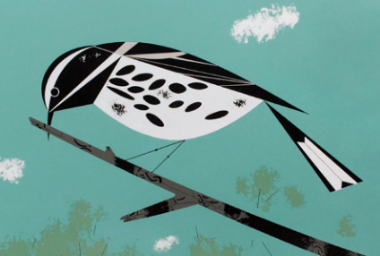
- Add colour, big blocks of colour, with stripes, and spots to differentiate features and parts of the bird
- Include a background – somewhere you would normally find this bird – a tree? a forest? a beach?

