**👶 Who Was Charley Harper?**

* **Name:** Charley Harper
* **Born:** **August 4, 1922**
* **Famous For:** Making bright, bold animal art using shapes like circles, triangles, and lines!

**🐞 What Did He Love to Draw?**

Charley loved animals most of all! His favourites were:

* 🐦 Birds
* 🐟 Fish
* 🐸 Frogs
* 🐞 Insects
* 🌸 Flowers
* 🌲 Trees and forests

He said nature was **funny, cute, and interesting** — and he wanted to show that in his art.

**🧒 Childhood Adventures**

Charley grew up on a **farm in West Virginia**.  
🌲 He loved **being outside**, watching animals and insects, and drawing what he saw.

Even as a kid, he liked to keep his drawings **simple and fun** — not too much detail!

**🎓 His Education**

📚 First, Charley went to **West Virginia Wesleyan College**.  
🎨 Then he studied art at the **Art Academy of Cincinnati**, where he learned how to paint and draw in his own creative way.

**👨‍🎨 His Art Career**

Charley Harper worked as a **professional artist** for many years!

🖼️ He made posters, magazine covers, book illustrations, and even art for nature parks.

Some fun facts about his career:

* He illustrated **The Golden Book of Biology**, a famous children’s science book 📘
* He made posters for the **U.S. National Parks** 🌳
* His art was used in nature centres and zoos all over the country
* He taught art at the **Art Academy of Cincinnati** (where he once studied!) 🎓
* He worked from home with his wife **Edie Harper** who was also an artist
* He created Harper Studios with Edie and son **Brett** Charley’s artwork became very popular because it was:

✔️ Bright  
✔️ Simple  
✔️ Full of animals and nature!

**🎨 What Was His Style Called?**

Charley called his art style **“minimal realism.”**

That means:

* He drew real things like animals...
* But he used **only basic shapes** to show them
* No tiny details — just the **most important parts**

He said:

“I don’t count feathers. I just count the wings. I see exciting shapes, colour combinations, patterns, textures, fascinating behaviour and endless possibilities for making interesting pictures.”

**🌟 His Most Famous Artwork**

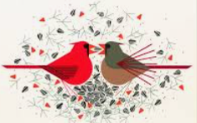Charley Harper made many amazing pieces, but here are a few that became especially **famous**:

**🐦 *“Red and Fed”***

Shows two bright red **cardinals** — one feeding the other a seed.

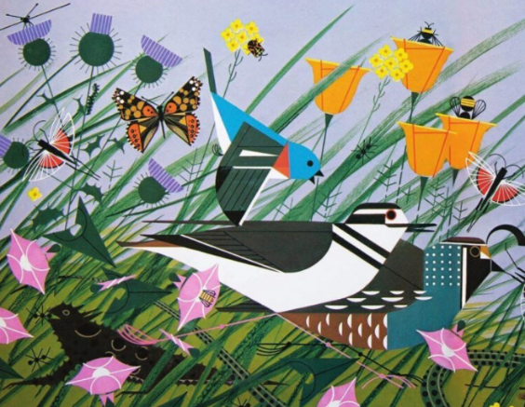A perfect example of **bold color and clean shapes**

**🌳 *“Once There Was a Field”***

A big piece with many tiny animals and birds hidden in a field of shapes.

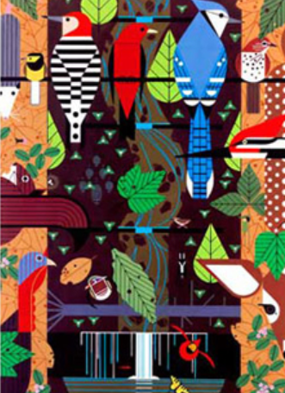It’s like a nature puzzle!

**🦉 *“Birducopia”***

A funny name (like "cornucopia") — it shows **a bunch of different birds** all together in one place, perched and peeking out!

These artworks are famous because they’re **beautiful, fun, and full of character**, even though they use only simple shapes and colours.

He created many illustrations, such as these for the Giant Golden Book of Biology:

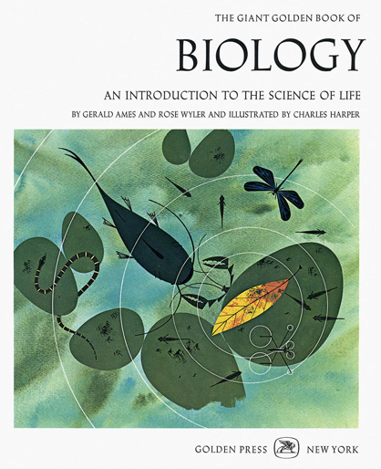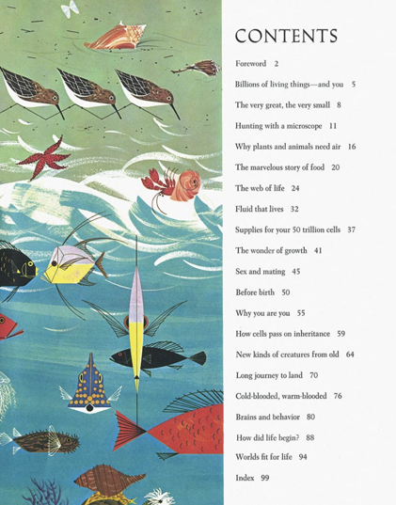

Ecosystems: Woodland forest 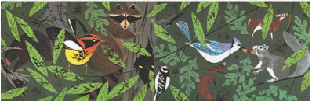

Prairie soil 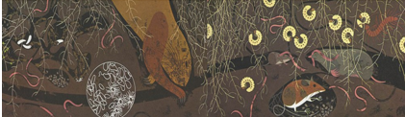

The desert at night 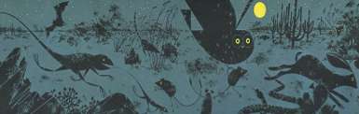

Famous people and their work, such as Gregor Mendel

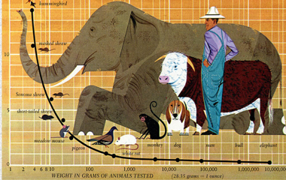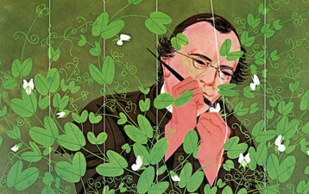

& Scientific theories and facts, such as Oxygen requirements v weight

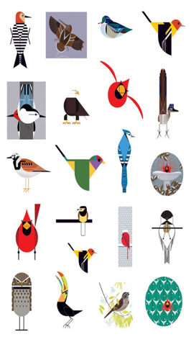

He is best known for his illustrations of birds