Maggi Hambling

🖌️ What does Maggi Hambling create?
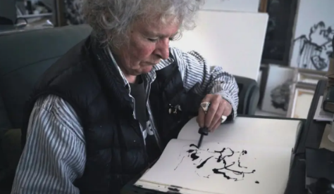
Maggi Hambling is a British artist who paints and sculpts. She’s known for her bold, emotional paintings and powerful public sculptures. Her work often shows movement and energy, like big crashing waves or expressive faces.

👧 Childhood
- Maggi was born in 1945 in Suffolk, England.
- As a child, she loved drawing and painting from an early age.
- Her parents supported her creativity and let her paint freely.
- She once painted a picture of her bedroom wall—right onto the wall itself!

🎓 Education
- Maggi went to the East Anglian School of Painting and Drawing when she was just 15.
- She studied at Ipswich School of Art, Camberwell College of Arts, and finally the famous Slade School of Fine Art in London.
- Her teachers encouraged her to be brave and honest in her artwork.
- She learned to use bold brushstrokes and deep emotions in her paintings.

💼 Career
- Maggi became famous for painting strong, expressive portraits—including famous people like George Melly and Francis Bacon.
- She created a huge sculpture called Scallop, which sits on the beach at Aldeburgh in Suffolk.
- Maggi has had many exhibitions in galleries all over the world.
- She was the first official artist-in-residence at the National Gallery in London!

💬 Quotes from Maggi
- “The moment between life and death is the most powerful of all.”
- “I like the idea of a painting painting itself.”
- “My best work is done when I forget myself.”

🎨 Art
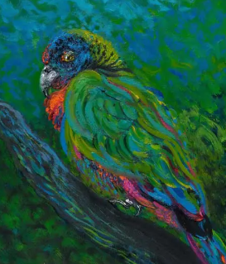
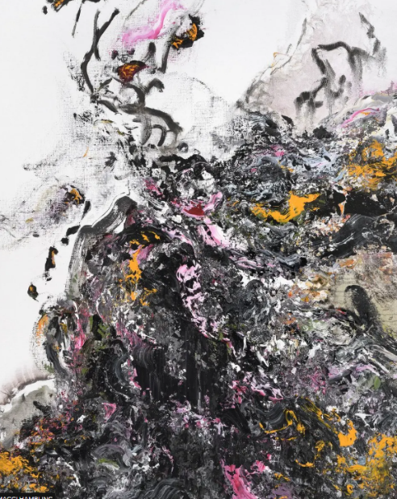

Covid Spring

Parrot in St Lucia

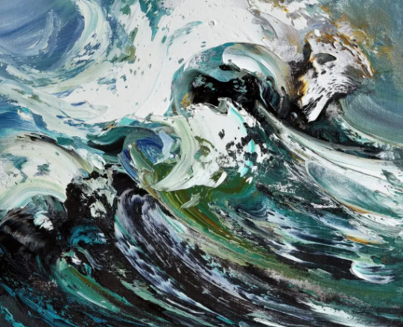
Crest of a wave

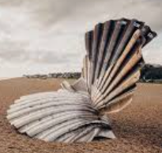

Scallop

