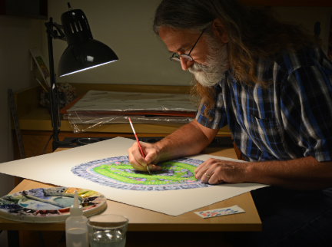
🎨 Who is David S. Goodsell?
David S. Goodsell is a scientist who uses watercolour paints to illustrate the tiny parts inside our cells, like proteins and viruses. His colourful paintings help people understand how life works at the microscopic level.
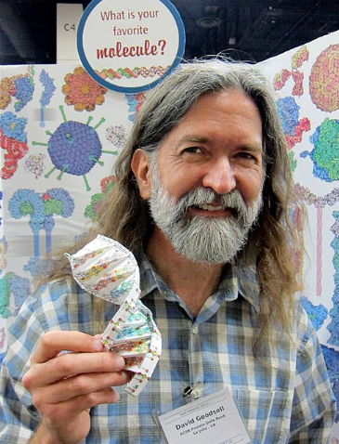

He combines science and art to make complex biology easier to see and learn about.

🧒 Childhood
- He enjoyed exploring the natural world and was curious about how things work, and he was interested in science and art from a young age.
- David learned to paint with watercolours from his grandfather, who taught him traditional scenes like barns and trees.
- His early experiences with painting influenced his unique style of scientific illustration
- He kept drawing while studying science—it helped him learn and explain ideas.

🎓 Education
- He earned a bachelor's degree in both biology and chemistry from the University of California, Irvine.
- He completed a Ph.D. in biochemistry in 1987.
- During graduate school, he developed molecular graphics programs to help create 3D models of cells.
- He did postdoctoral research at The Scripps Research Institute, focusing on molecular biology.
- He earned a Ph.D. in X-ray crystallography, a method used to see molecules, at the University of California, Los Angeles.

🧪 Career
- He is a professor of computational biology at The Scripps Research Institute
- He also works with the RCSB Protein Data Bank, which collects 3D models of molecules.
- He developed AutoDock, a widely used program for molecular docking in drug design.
- He has written several books, which combines science and art to explain cellular processes, including The Machinery of Life.
- He gives talks about the beauty of molecular biology.

🖼️ Artwork
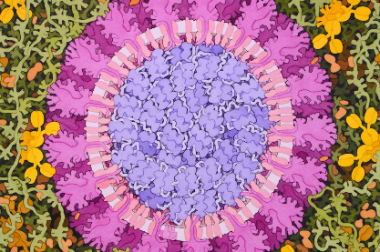
- Coronavirus (2020): A detailed watercolour painting showing the structure of the coronavirus

- He created the "Molecule of the Month" series for the RCSB Protein Data Bank, illustrating molecular structures.
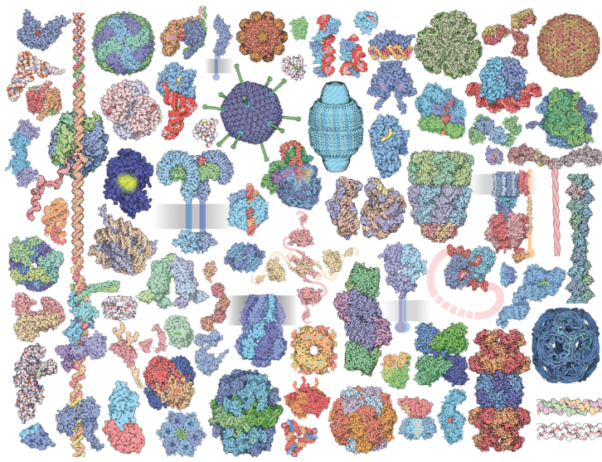

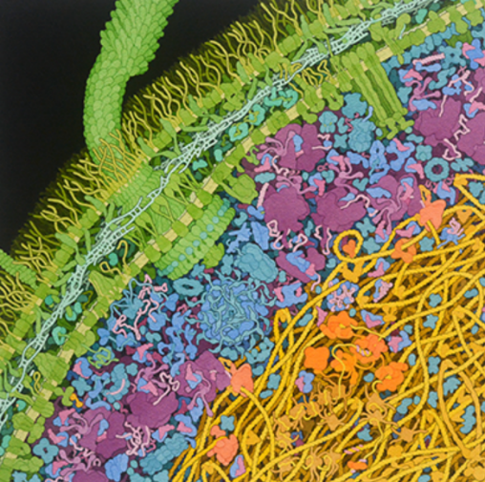

- Escherichia coli Bacterium: A painting showing the internal structure of the E. coli bacterium.

💬 Quotes from David S. Goodsell
- "To make things even more challenging, cells must also be able to make all of their component molecular machines using only the resources that are available in the local environment."
- "The key molecular process that makes modern life possible is protein synthesis, since proteins are used in nearly every aspect of living."
- “I want to show how crowded and active cells really are.”
- “Science is full of beauty. I try to bring that to life with art.”
- “You don’t need to choose between art and science—you can do both!”

📚 Bibliography
- RCSB Protein Data Bank: molecule of the month
- Interview with ASBMB: https://www.asbmb.org/asbmb-today/people/080111/david-goodsell-the-master-of-mol-art
- Goodsell, D. S. (1993). The Machinery of Life. Springer-Verlag.
- Goodsell, D. S. (1996). Our Molecular Nature: The Body's Motors, Machines, and Messages. Springer-Verlag.
- Beautiful Now
- Zócalo Public Square
- Wikipedia

🎨 Art Challenges

🎨 1. Microscopic Art Challenge
- Draw your version of what a cell or virus might look like!
- Colour it
🧠 Extension: Label basic parts like the nucleus or virus spikes.

🧬 2. Build a Cell from Craft Materials
- Use clay, felt, pipe cleaners, or sweets (jelly = cytoplasm!).
- Assign each craft item to a different cell part.

🔍 3. "Design Your Own Microbe" Activity
Goal: Invent a brand-new microbe!
- What shape is it? What does it do? Is it helpful or harmful?
- draw your microbe and write a short story or label its parts.
- Give it a name, size, and “superpowers.”
Colouring page inspired by David S. Goodsell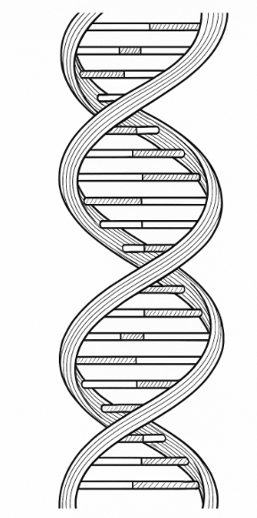

Colouring page inspired by David S. Goodsell

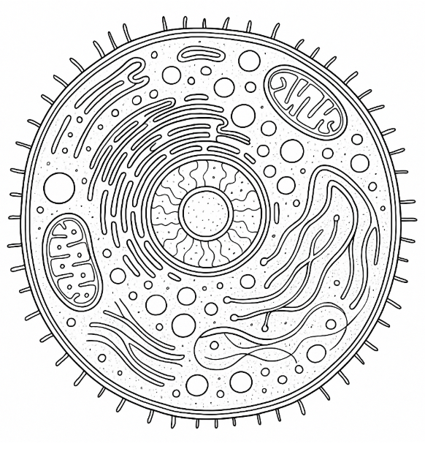

Colouring page inspired by David S. Goodsell

