Andy Goldsworthy

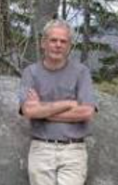
🎨 What Does Andy Goldsworthy Create?
Andy Goldsworthy is a land artist who makes beautiful and surprising art from natural things like leaves, ice, stones, twigs, and flowers. He often creates his work outdoors in nature, using what he finds around him. His art sometimes lasts only a few hours before the wind, rain or sun changes it!

👶 Childhood
- Andy was born in Cheshire, England in 1956.
- He grew up in Yorkshire, a place full of beautiful countryside.
- As a child, he loved exploring fields and woods near his home.
- He started working on farms as a teenager, which taught him how to use his hands and connect with nature.

🎓 Education
- Andy studied art at Bradford College of Art (1974–1975).
- Then he went to Preston Polytechnic to study Fine Art (1975–1978).
- He experimented with using natural materials during his studies.
- He realised he wanted to create art outside in the landscape, not in a gallery.

💼 Career
- Andy travels around the world to make art in forests, beaches, deserts, and snowy mountains!
- He photographs all his creations, because many of them don’t last long.
- He made a famous outdoor sculpture trail at the Yorkshire Sculpture Park.
- He was awarded the OBE (Order of the British Empire) in 2000 for services to art.

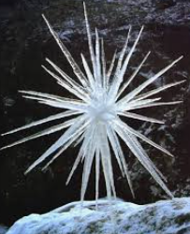
🖼️ Artworks
Icicle Star - A star shape made of icicles
Rowan Leaves and Hole - A ring of bright red leaves with a black hole in the middle
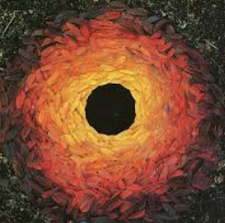

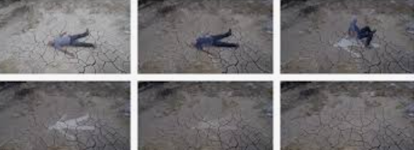
Rain Shadows – He lies down in the rain and gets up to leave a dry shape behind

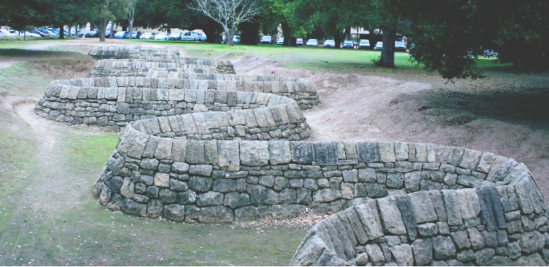
Stone River – A long winding sculpture made of broken stone in California

💬 Artist Quotes:
- "I want to understand that state of mind where you can be truly amazed by the world."
- "My art is an attempt to reach beyond the surface appearance. I want to see growth in wood, time in stone, nature in a city."
- "It's not about art, it's about life and the need to understand it."

