**Walt Disney**

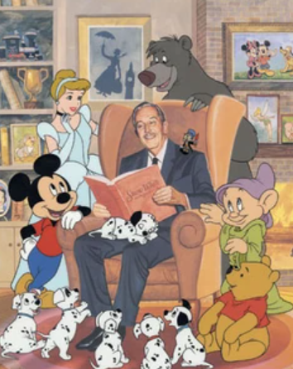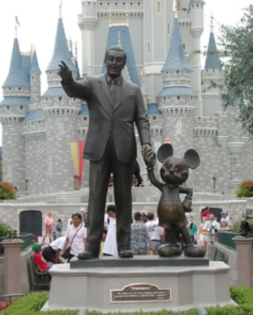

https://disney.fandom.com/wiki/Walt_Disney

**👦 Childhood:**

* Walt Disney was born on December 5, 1901, in Chicago, Illinois, USA.
* He grew up on a farm in Missouri, where he developed a love for animals and nature.
* As a boy, Walt loved drawing and sold his sketches to neighbours to earn a little extra money.
* He was a paperboy in his early teens, delivering newspapers for his father’s business.

**🎓 Education:**

* Walt attended McKinley High School in Chicago, where he took drawing and photography classes.
* He also attended evening classes at the Chicago Academy of Fine Arts to improve his drawing skills.
* Walt loved drawing cartoons for his high school’s newspaper.
* He dropped out of high school at 16 to join the Red Cross during World War I, where he drove an ambulance in France.

**🎨 Career:**

* Walt co-founded the Disney Brothers Studio (later The Walt Disney Company) with his brother Roy in 1923.
* He created Mickey Mouse in 1928, which became one of the world’s most beloved characters.
* Walt produced the first full-length animated feature film, 'Snow White and the Seven Dwarfs,' in 1937.
* He opened Disneyland in California in 1955, creating a new form of family entertainment.

**🖼️ Famous Creations:**

* Mickey Mouse 🐭 – The cheerful and brave cartoon mouse loved worldwide.
* Donald Duck 🦆 – The grumpy but lovable duck with a distinctive voice.
* Snow White and the Seven Dwarfs 👸 – The first-ever full-length animated feature film.
* Disneyland 🏰 – The first theme park of its kind, designed as a place where families could have fun together.

**💬 Famous Quotes:**

* “All our dreams can come true, if we have the courage to pursue them.”
* “It’s kind of fun to do the impossible.”
* “Laughter is timeless, imagination has no age, dreams are forever.”
* “The way to get started is to quit talking and begin doing.”

**🎲 Fun Activities:**

* Draw your own cartoon character – What would they look like? What’s their name?
* Create a short comic strip about an adventure at a magical kingdom.
* Act out your favourite Disney movie scene – Use costumes or props if you have them!
* Build your own paper castle or theme park using cardboard and craft materials.