**Jim Dine**

**🧰 What Does Jim Dine Create?**

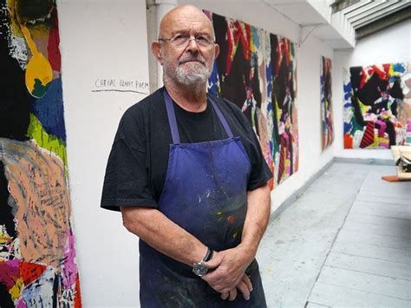

Jim Dine is a famous American artist who loves turning everyday objects into colourful and expressive artworks. He often paints hearts, tools, robes, and flowers. His work is full of bright colours, strong lines, and emotion.

**🧒 Childhood Facts**

* Jim was born in Cincinnati, Ohio, in 1935.
* He spent lots of time in his grandfather’s hardware shop, which inspired his love for tools.
* He enjoyed drawing and painting from a young age.
* After his mother died, he lived with his grandparents who supported his creativity.

**🎓 Art Education**

* Jim began studying art at the University of Cincinnati.
* He continued his studies at the Boston Museum School.
* He later studied at Ohio University and earned his degree in Fine Art.
* His time at university helped shape his unique style.

**🎨 Art Career**

* Jim Dine became known during the Pop Art movement, though his style was more personal and expressive. He used a traditional symbol of love, the heart to explore its meaning and relevance
* He took part in creative performance art called “Happenings” in New York.
* His artworks have been shown in many exhibitions all around the world.
* Even in his 80s, he continues to create new artworks and poems.

**🖼️ Famous Artworks**

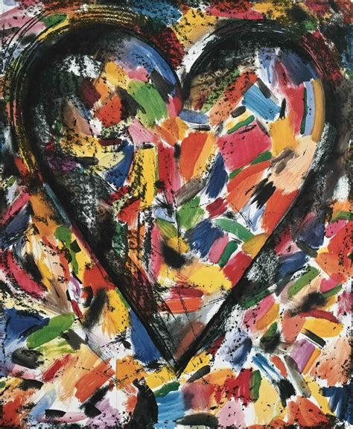Four Hearts

Confetti Heart

Double Isometric Self-Portrait

The Five Hammer Etudes

Twelve colourful tools

**🗣️ Jim Dine Quotes**

* “Drawing is everything, because it helps me start all my ideas.”
* “I work every day. I’ve never had a holiday.”
* “The human figure is full of emotion. That’s why I use it.”