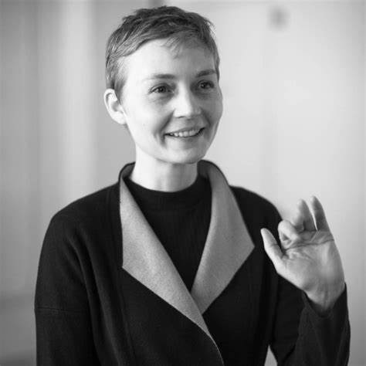
👧 Who is Heather Dewey-Hagborg?
Heather is an artist and scientist who makes art from DNA – that’s the tiny code inside your body that makes you you!
She’s famous for turning science into art, and making people think about identity and privacy.

🏠 Her Childhood
- Heather was born in the United States.
- As a child, she loved science experiments, computers, and making things.
- She was super curious – always asking why and how things work.

🎓 Her Education
- Heather studied theatre and computers in school.
- She went to Bennington College and later studied art and technology.
- She earned a PhD in Electronic Arts – that means she learned to use computers and science in her artwork!

💼 Her Jobs
- Heather is a bio-artist – that means she uses biology and technology to make art.
- She also teaches students about art and science.
- She works with scientists and labs to do real experiments!
- She has worked as a Visiting Assistant Professor of Interactive Media at NYU Abu Dhabi, where she taught courses such as Communication and Technology, Understanding Interactive Media, and Bioart Practices
- She has been an Artist-in-Residence at the Exploratorium in San Francisco
- Her teaching roles have also included positions at the School of the Art Institute of Chicago, NYU's Interactive

🎨 Her Art
- Her work has been exhibited internationally at venues such as the Centre Pompidou in Paris, the Victoria and Albert Museum in London, and the New York Historical Society.
- Her work is not in a conventional art form.
- Her projects often explore the intersection of art and science, with a focus on genetic privacy and surveillance. ​
- For example: How Do You See Me? is a new work commissioned as part of Data/Set/Match, a year-long Digital programme exploring the ever-evolving role and effects of scientific image datasets
- Her most famous project is called Stranger Visions
- She picked up chewing gum, hair, and cigarette ends from the street.
- Then she looked at the DNA left behind.
- She used computers and science to guess what the person might have looked like!
- Then she made 3D faces from that information.
- It was like solving a mystery using science and art!

❓Why is Her Art Important?
- It makes people think:
  - Should we use DNA to know what people look like?
  - Is it okay to take someone’s DNA without asking?
- Her art helps us think about privacy, identity, and the future.

🧠 Fun Fact!
Heather once said:
“I want people to question how much information they leave behind.”

✏️ Time to imagine!
- Create a project in which you collect data from people and make art from it

- Imagine being able to programme ChatGPT with information you have gathered from people, what could you programme into it, and what art do you think it could create?

