Edgar Degas
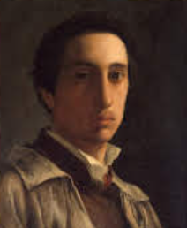
🖌️ What Did Edgar Degas Create?
Edgar Degas was a French artist known for painting dancers, racehorses, and everyday people. He loved to show movement in his art and used painting, drawing, pastels, and sculpture.

👶 Childhood
- He was born in Paris, France, in 1834.
- His full name was Hilaire-Germain-Edgar Degas.
- His father was a banker, and his mother was from New Orleans, USA.
- As a child, he loved to draw and often visited art museums with his family.

📚 Education
- Degas went to a special school in Paris called Lycée Louis-le-Grand.
- He studied law for a while but didn’t enjoy it.
- He later trained at the École des Beaux-Arts, a famous art school.
- He also studied by copying paintings at the Louvre Museum.

🧑‍🎨 Career
- Degas showed his work in exhibitions with the Impressionists, though he had his own style.
- He created over 1,500 works of dancers – ballet was his favourite subject!
- He became friends with artists like Manet and Monet.
- Later in life, he had trouble with his eyesight but kept working with sculpture and drawing.

🖼️ Artworks

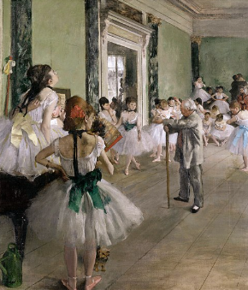
The Ballet Class Dancers Practicing at the Barre
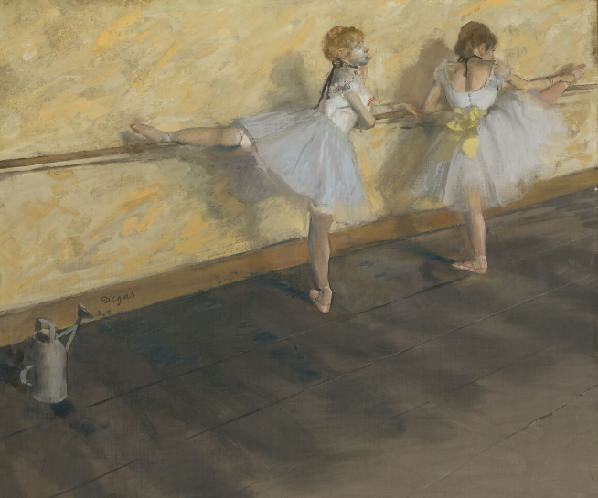

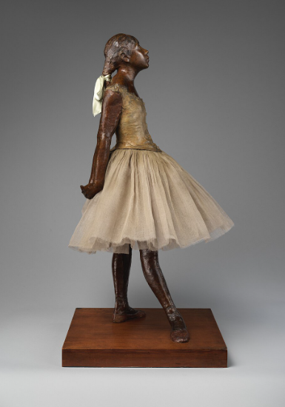
Little Dancer of Fourteen Years
Dancers Backstage
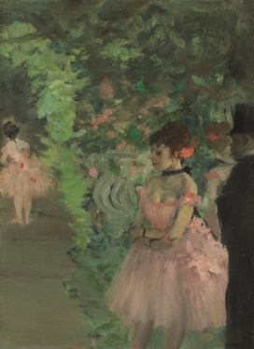

Racing horses (a series)
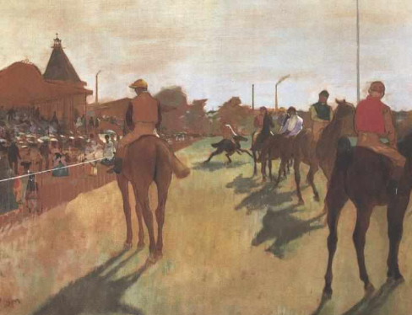

🗣️ Quotes from Degas:
- “Art is not what you see, but what you make others see.”
- “Painting is easy when you don’t know how, but very difficult when you do.”

