Salvador Dalí

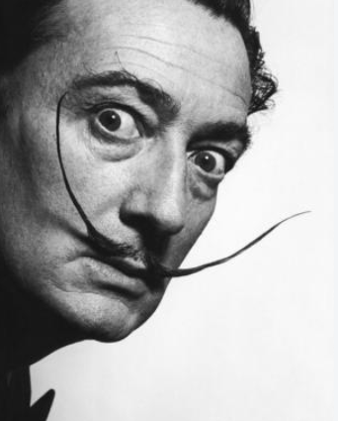
🧠 Who Was Salvador Dalí?
Salvador Dalí was a famous Spanish artist known for his surreal and dream-like paintings. He painted things that looked like they were from a dream – melting clocks, floating elephants, and strange landscapes.

👶 Childhood
- Dalí was born in 1904 in Figueres, Spain.
- He loved drawing from a young age and was very imaginative.
- His parents encouraged his creativity and gave him a painting studio at just 12 years old.
- He once had a pet bat and loved dressing in unusual clothes, even as a child!

🏫 Education
- Dalí studied at the Academy of Fine Arts in Madrid.
- He got in trouble at school for questioning teachers and breaking rules!
- He admired Renaissance artists and learned classical painting techniques.
- He was influenced by surrealist writers and philosophers while studying.

🎭 Career
- Dalí became one of the most famous Surrealist artists in the world.
- He worked with Walt Disney on a short animated film called Destino.
- He also designed sets for plays and movies, and even made jewellery.
- Dalí built the Dalí Theatre-Museum in his hometown – where he’s buried!

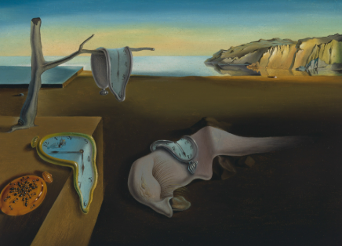
🖼️ Artworks
The Persistence of Memory

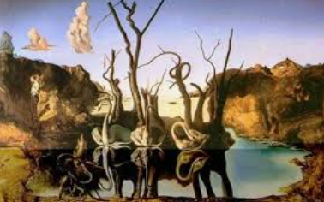
Swans Reflecting Elephants

The Elephants
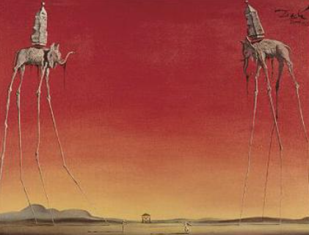
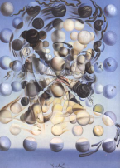
Galatea of the Spheres

💬 Quotes from Salvador Dalí
- "Have no fear of perfection – you'll never reach it."
- "Surrealism is destructive, but it destroys only what it considers to be shackles limiting our vision."

