**Who was Leonardo da Vinci?**

* **Leonardo** was a **polymath** – a person who is good at lots of different things!
* The word **"polymath"** comes from Greek and means "**having learned much**".
* In Leonardo’s time, **Renaissance Italy** (during the 15th and 16th centuries), people were encouraged to try everything!
* Today, people usually specialise in one thing, like being an artist, scientist, or architect — but Leonardo did it all!

Leonardo wasn’t just an artist — he was amazing at lots of things! He was a:

* 🖌 Painter
* 🎨 Sculptor
* 🏰 Architect
* 🎵 Musician
* ➗ Mathematician
* ⚙️ Engineer
* 💡 Inventor
* 🫀 Anatomist (studying the human body)
* 🪨 Geologist (studying rocks)
* 🗺 Cartographer (making maps)
* 🌿 Botanist (studying plants)
* ✍️ Writer

**🌟 Fun Facts About Leonardo**

* He was **born in Vinci**, Italy, in **1452**.
* He **loved sketching** — he carried notebooks everywhere!
* His most famous paintings are the **Mona Lisa** and **The Last Supper**.
* Even today, people are still inspired by his amazing ideas!

**Education**

* At **14 years old**, Leonardo became an apprentice to a famous artist named **Verrocchio**.
* By **20**, he was a **master artist**!

**Studying**

* Leonardo loved to study **how things work**.
* He carefully drew parts of the human body, like **hands and bones**, to understand them better.
* His advice to artists: "**Learn the basics before rushing**."

**Creating Imaginary Scenes**

* Leonardo didn’t just copy what he saw — he made **new scenes** by combining his sketches.
* In **The Last Supper**, he placed Jesus in the centre with groups of disciples around him, making a balanced and interesting picture.
* He had collected sketches of various people, and he used them to create this picture

[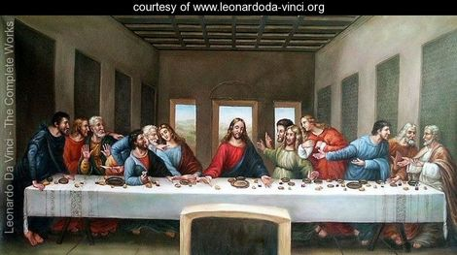](http://www.leonardoda-vinci.org/The-Last-Supper-1498-large.html)

**The Magic of Math in Art**

Leonardo used math to make his art beautiful!

* **Golden Ratio:** A special number (1:1.618) found in nature, art, and architecture.
* **Golden Shapes:** He used golden rectangles, triangles, and pyramids to plan paintings like the **Mona Lisa** and **Madonna of the Rocks**.

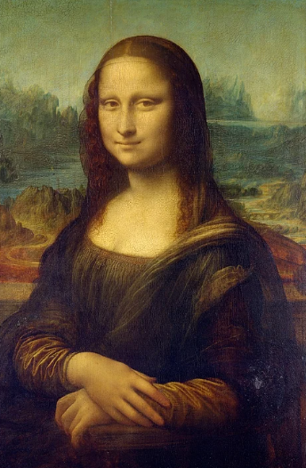 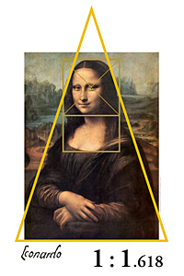

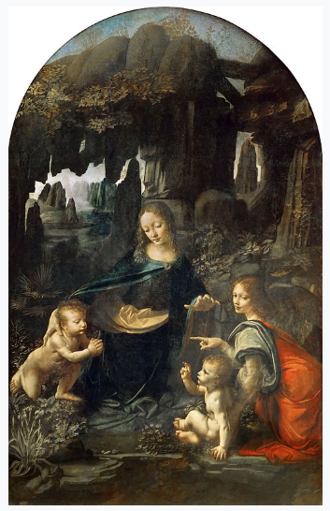 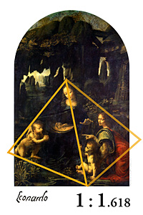

Several of da Vinci's paintings are believed to incorporate the golden ratio, also known as the Divine Proportion or Divine Ratio. These include The Last Supper and Mona Lisa

In Leonardo's Last Supper fresco, the Golden Ratio (rear wall and windows) and other relationships based on Fibonacci Numbers (foreground, table and disciple's feet) may be found in the relationship of elements

* **Perspective:** He used **vanishing points** to make flat paintings look 3D!

✅ **Key Idea:**  
The vanishing point is where straight lines (like roads, railway tracks, or the edges of buildings) **seem to join together** when they are far away from you.

Imagine standing on a straight road. When you look far, far ahead, the two sides of the road seem to get closer together until they almost meet at one tiny point.  
That tiny point is called the **vanishing point**!

The vanishing point can be anywhere. The vanishing point is where all parallel lines (orthogonal) that run towards the horizon line appear to come together like train tracks in the distance.

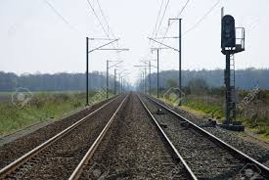

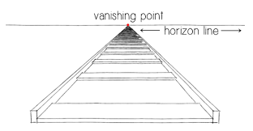

Artists use vanishing points when they want to make their drawings look **real** and **3D**, like you could walk right into them!

**Leonardo the Inventor**

* Leonardo sketched machines, like a **helicopter** and **weapons**.
* He imagined amazing inventions, even if he didn’t always get the science 100% right.
* 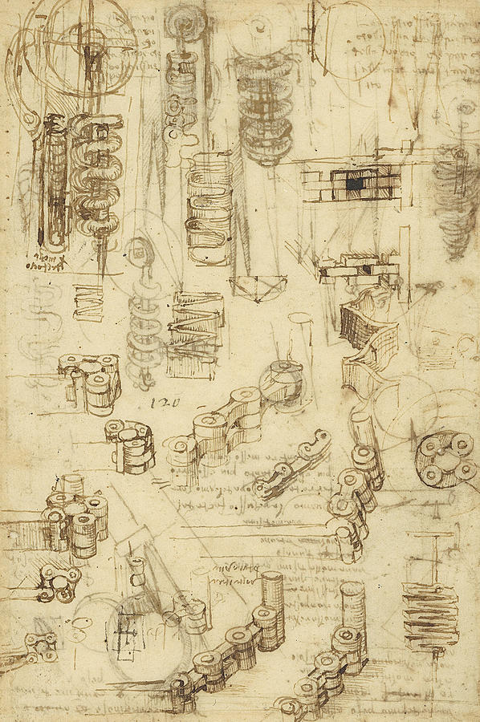
* Leonardo studied all kinds of mechanical objects, thinking how each one worked as he drew and exploring possible new concepts. His inventions were very important to modern mechanical engineering, although he did not always get things right because he lacked an understanding of physics, chemistry and engineering principles which were not discovered until recently.
* This image is Leonardo da Vinci's 15th century sketch of a "helical air screw," drawn nearly 400 years before the first helicopter was built.

Air Velo, a Canadian company, used this to design a helicopter, however, the one originally devised by Leonardo was powered by two men walking around the base disc and theirs was powered by one man on a bicycle powering several small rotating engines which flew the helicopter.

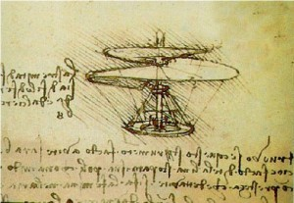

* Unfortunately Leonardo was very famous for drawing weapons! He applied his logic to the creation of some fearsome machines. Here are drawings of a breach loading swivel gun and one made from the drawings.

