⭐**Some ideas and activities to help you get to grips with Da Vinci’s ideas**

⭐ **Idea 1:** Practice drawing simple shapes carefully.

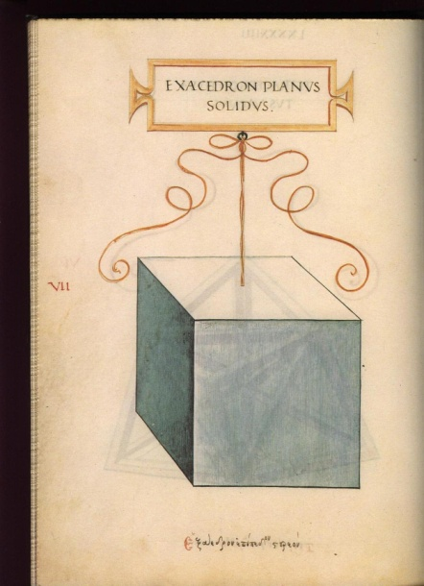Leonardo took pride even when he created simple shapes.

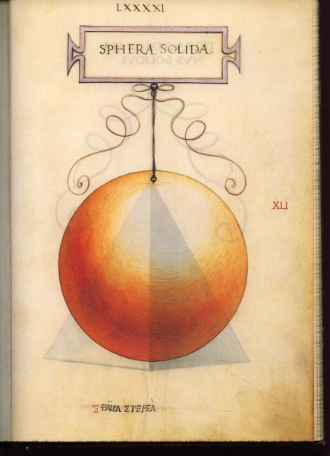

He worked hard when illustrating a book called Summa de arithmetica, geometrica, proportioni et proportionalita, for a friar called Luca Pacioli.

These illustrations show simple shapes to perfection.

Leonardo sketched everything all the time. He then had many, many examples of work to use when he compiled images for his paintings.

**Task 1:** Try sketching a block or a ball — measure them to get them just right!

⭐ **Idea 2:** Look closely at your hand — draw it in different poses!

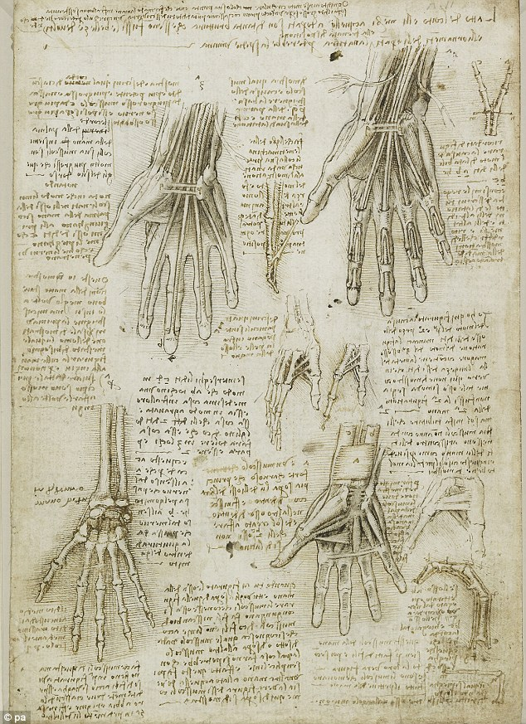

Leonardo was very interested in how people are put together and he worked extensively on illustrating the human body.

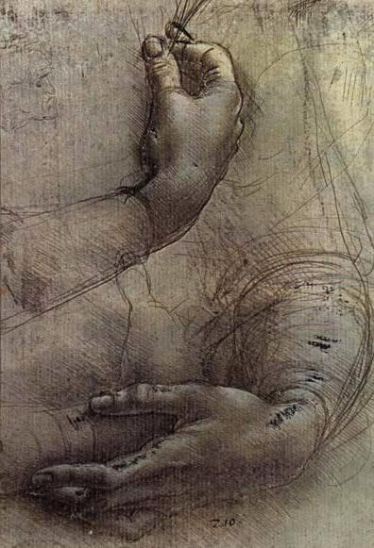Here he examines how the hand bones hold together; with knowledge like this he was able to create beautiful hands.

**Task 2:** Notice how your fingers move and sketch what you see.

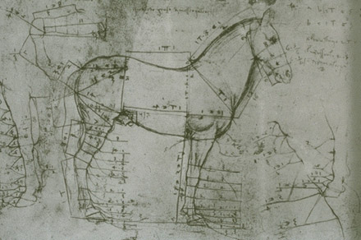⭐ **Idea 3:** Use your sketches to create your own scene!

Leonardo sketched all the time, he liked to draw everything he saw.

He often used work he had practised in his sketch book when putting together ideas for paintings.

Here are some of his sketches of horses, and some perspective pieces of stairs and columns.

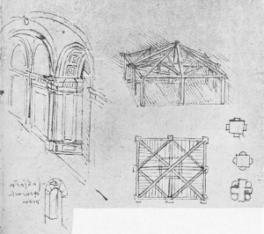

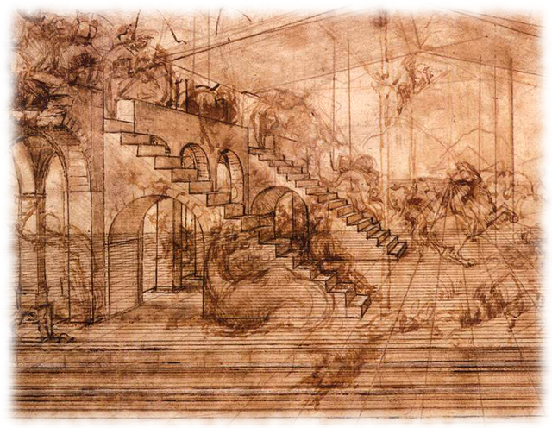

Using work like this he created new work, such as ‘The Adoration of the Magi’ – you can see one of his horse sketches in the background and the columns on the left-hand side.

**Task 3:** Create different sketches, then put them together to make one new picture.

⭐ **Idea 4:** Try some Ancient maths theories in your art!

The study of the world was important to the ancients, and they studied Botany as it was the work of God, thus divine, during their studies they found mathematical rules

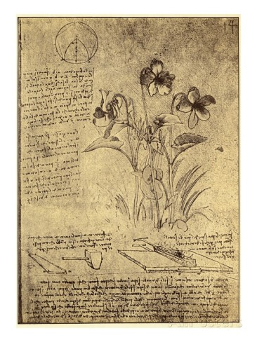

Here are some of Leonardo’s botanic illustrations. They are not just illustrations though, they are studies, where Leonardo works through ideas about patterns.

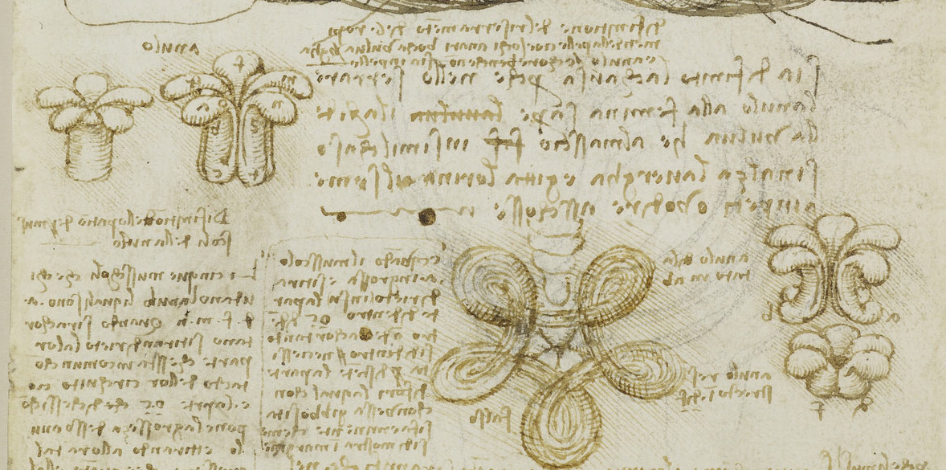

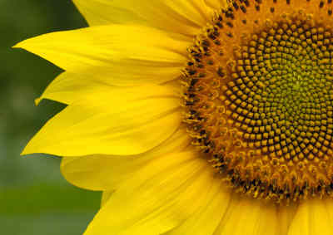

Plants can grow new cells in spirals, such as the pattern of seeds in a sunflower.

The spiral happens naturally because each new cell is formed after a turn.

"New cell, then turn, then another cell, then turn, ..."

If you don't turn at all, you get a straight line http://www.mathsisfun.com/numbers/images/seeds-straight-line.jpg

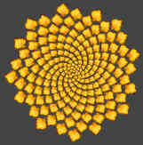

If you are a plant, a turn of 0.618 works perfectly. This was such an obvious pattern, and it was replicated throughout the natural world so much it was obviously important.

**Task 4**

Go outside, find plants, sketch them and see if you can spot patterns in their growth, if it’s the right time of the year you may be able to see the sunflowers pattern.

⭐ **Idea 5:** Find the vanishing point in pictures!

Can you spot the vanishing point in these pictures?



**Task 5:** Look at photos or paintings — can you see where the lines meet?

⭐ **Idea 6:** What’s important?

A good picture shows its subject to its best advantage.

****Which of these pictures is balanced successfully and shows the yacht to the best advantage? How would you improve the ones which are not showing the boat to the best advantage?







****Also, it’s important to position the subject at the right distance. Which of these is the best photo of the red boat? Why?



**Task 6:** Create a picture which shows something you are passionate about (like animals, sports, or space). Put your subject in a central position, and make them big. Think carefully about the background you will use behind the subject, don’t add anything which will distract people and make them look away from the subject, instead, try adding things that will enhance the subject, or tell us more about them. Colouring page inspired by Madonna of the Rocks