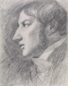
John Constable

🖌️ What did John Constable create?
John Constable was a famous English painter best known for his beautiful landscapes. He painted scenes of the countryside, especially around his home in Suffolk. His artwork often shows fields, rivers, clouds, trees, and farms — all in great detail.

👶 Childhood
- John was born in 1776 in a village called East Bergholt in Suffolk, England.
- His father was a wealthy corn merchant and mill owner.
- John loved to sketch outside as a child and often wandered through the countryside with a pencil and paper.
- He was expected to work in the family business, but his heart was always in painting.

🎓 Education
- At age 23, John persuaded his family to let him study art seriously.
- He joined the Royal Academy of Arts in London in 1799.
- He studied paintings by famous artists like Claude Lorrain and learned how to use light and shadow.
- He practiced by sketching real-life scenes outdoors, known as plein air painting.

👨‍🎨 Artwork
- John Constable became known for painting the landscapes of “Constable Country” — especially the River Stour and Flatford Mill.
- His work was not popular in England at first, but it was loved in France.
- He became a Royal Academician in 1829 – a great honour for any artist.
- Later in life, he also gave lectures on landscape painting and art.

🖼️ 4 Famous Artworks He Created
The Hay Wain 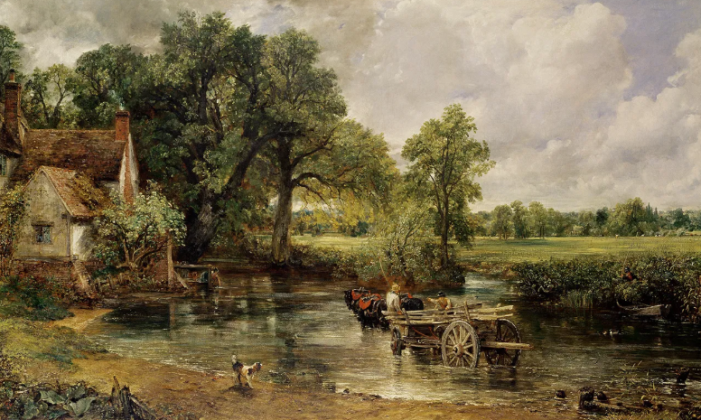
Flatford Mill 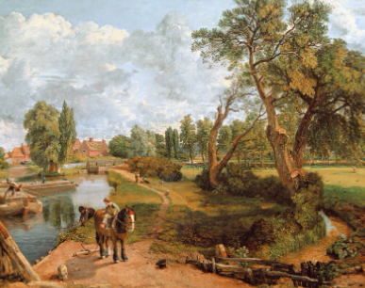
The Vale of Dedham 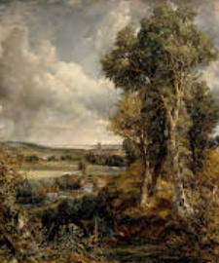
Salisbury Cathedral from the Meadows 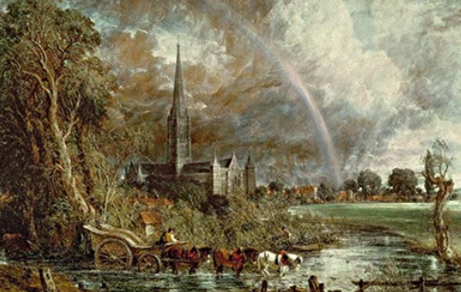

🗣️ Quotes from John Constable
- “Painting is but another word for feeling.”
- “The sound of water escaping from mill dams… willows, old rotten planks… I love such things.”
- “I never saw an ugly thing in my life.”
- “The world is wide, no two days are alike, nor even two hours.”

