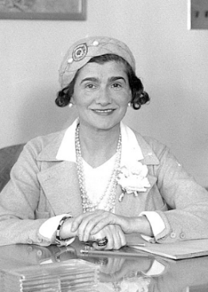
Coco Chanel

👗 What Did Coco Chanel Create?
Coco Chanel was a famous fashion designer who changed the way people dressed. She made clothes that were simple, elegant, and comfortable.
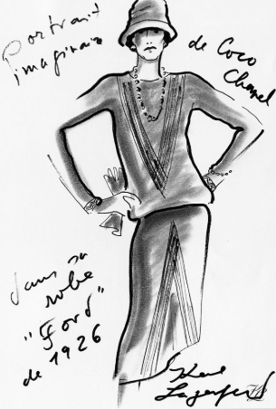

She didn’t draw her designs in the way other fashion designers do, she designed them by cutting and sticking and manipulating fabric

🧒 Childhood Facts
- Her real name was Gabrielle Bonheur Chanel.
- She was born on 19 August 1883 in Saumur, France.
- Coco’s mother died when she was young, and she was sent to an orphanage.
- She learned to sew from the nuns who looked after her.

🏫 Education
- She didn’t go to a fashion school.
- She learned sewing and embroidery in the orphanage.
- She worked for a time as a seamstress.
- She later trained as a milliner (hat maker).

💼 Career
- Opened her first hat shop in Paris in 1910.
- Became famous for designing clothes that freed women from corsets.
- Created the famous Chanel No. 5 perfume in 1921.
- Her fashion house, Chanel, is still one of the most famous in the world today.

💬 Quotes from Coco Chanel
- “Beauty begins the moment you decide to be yourself.”
- “In order to be irreplaceable one must always be different.”
- “Fashion fades, only style remains the same.”
- “Simplicity is the keynote of all true elegance.”

🖼️ Creations
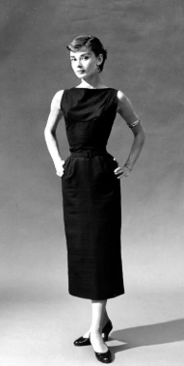
The Little Black Dress Comfortable dresses
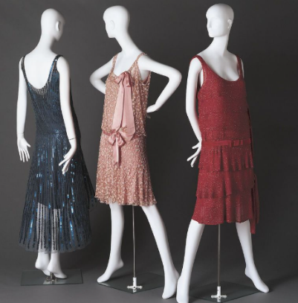

The Chanel Suit
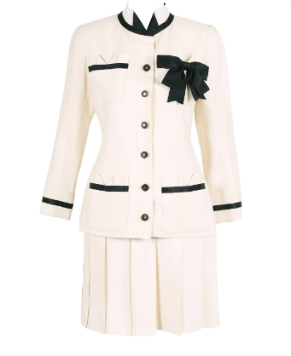

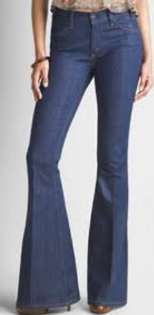

Bell bottom trousers
The Quilted Handbag
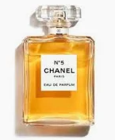
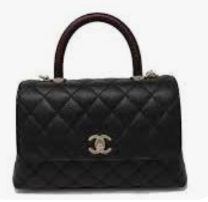
Chanel No. 5 Perfume

