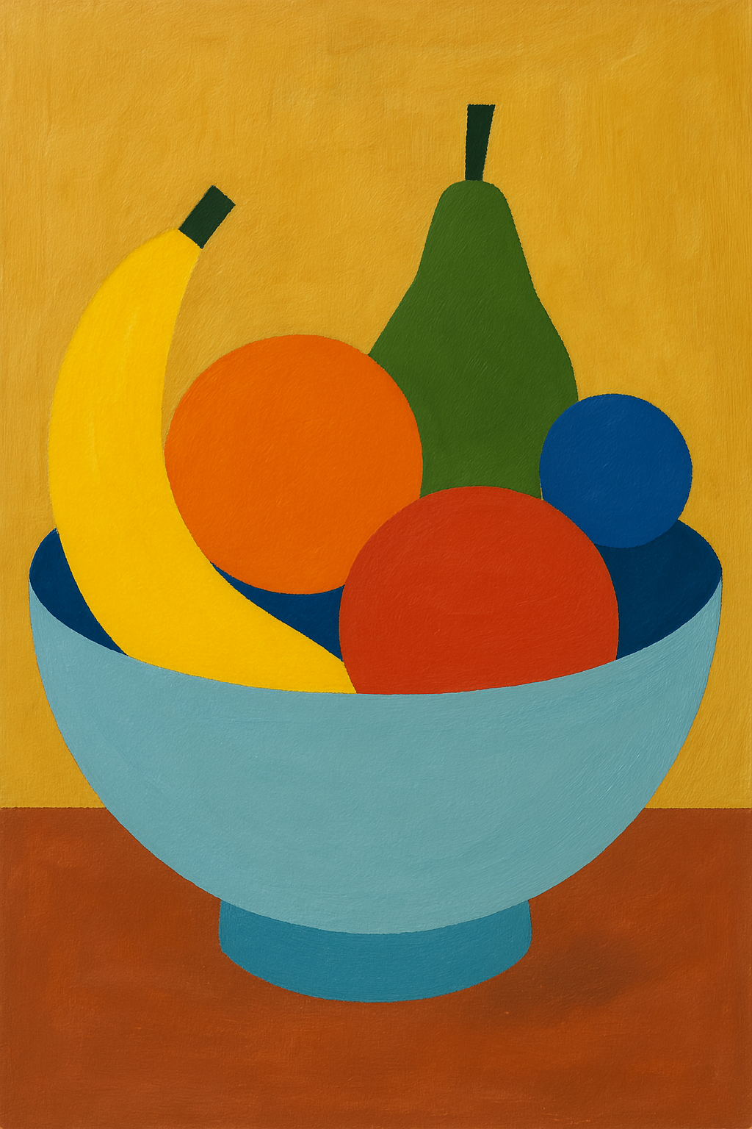**Would you like to try creating like Cézanne?**

Grab some paper and colours and cut out some shapes - create a bowl of fruit using only shapes! 🍏🍊🍌

Try creating a tree using only circles, squares, and triangles! 🌳 🎨

Try creating a mountain using only shapes like circles, squares, and triangles! 🌳 🏔️