Mary Cassatt
🖼️ What Did Mary Cassatt Create?
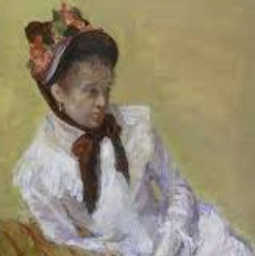
Mary Cassatt was an Impressionist painter who is best known for painting pictures of mothers and children. Her artwork is gentle, full of love, and often shows the everyday life of families. She used soft brushstrokes and beautiful colours.

👧 Childhood
- Mary was born in Pennsylvania, USA, in 1844.
- She loved art from a young age and visited museums when travelling in Europe.
- Her family was quite wealthy and wanted her to learn to be a lady—not an artist!
- She had six siblings and grew up in a busy, well-educated family.
🎓 Education
- Mary studied art at the Pennsylvania Academy of the Fine Arts at age 15.
- She was frustrated because women weren’t treated equally in art schools.
- She moved to Paris, France, to study painting—this was a brave move at the time!
- She copied famous artworks at the Louvre Museum to learn how to paint.
🎨 Career
- Mary became friends with Edgar Degas, who invited her to join the Impressionists.
- She showed her art in Paris exhibitions, where people admired her soft, loving scenes.
- She often painted mothers, children, and family moments.
- She supported women’s rights and helped more women become artists.
🖌️ Artwork
Young Mother Sewing The child’s bath
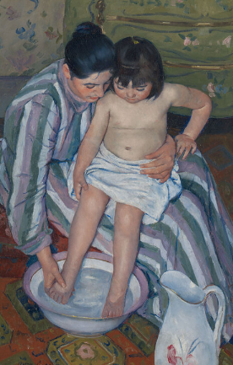
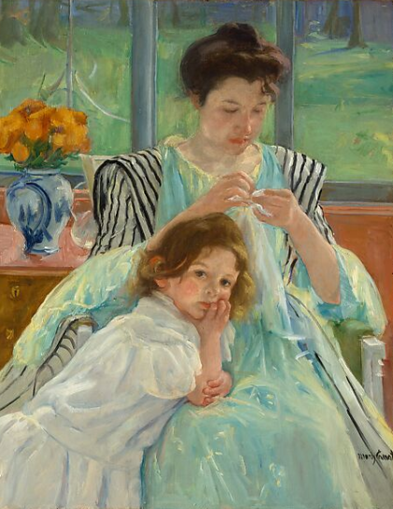

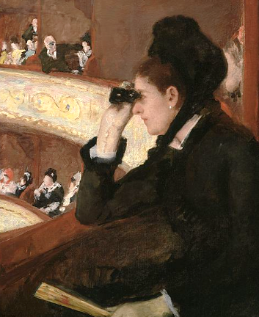
In the Loge

💬 Quotes from Mary Cassatt
🖌️ "I love to paint women and children just as they are."
🎨 "There’s only one thing in life for a woman; it’s to be an artist."

