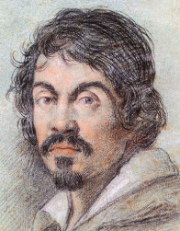
Michelangelo Merisi da Caravaggio
Born: 29 September 1571
Known for: Dramatic paintings using strong contrasts of light and dark (a style called chiaroscuro)

🖌️ What Did Caravaggio Create?
Caravaggio painted realistic and emotional scenes, often showing:
- People from the Bible or ancient stories
- Regular people as models, not idealised figures
- Dramatic lighting with deep shadows and bright highlights
- Real emotions like fear, surprise, and pain

👶 Childhood
- Born in the town of Caravaggio in northern Italy (that’s where he got his name!)
- His father was a stone mason and architect
- Lost both his parents before he was 12 years old
- Moved to Milan with his uncle after his parents died
- Grew up during a time of great art and learning (the late Renaissance)

🎓 Education
- At around age 13, he became an apprentice to Simone Peterzano, a well-known painter in Milan
- Simone Peterzano had trained in the Venetian style, which used rich colours and soft light — this influenced Caravaggio’s early style
- As an apprentice, Caravaggio learned:
  - How to mix paints
  - How to prepare canvases
  - How to paint figures and still life
  - How to study live models and sketch from life
- He also studied the works of Titian and other great Venetian painters
- Moved to Rome in his early twenties where he continued to learn by:
  - Visiting churches and galleries
  - Copying the works of masters
  - Sketching real people in everyday life

💼 Career
- Became famous in Rome for his lifelike and emotional paintings
- Often used everyday people like beggars and farmers as models
- Known for making Bible stories feel real and dramatic
- Got into trouble often—he had a fiery temper and even had to flee Rome after a fight
- Worked in Naples, Malta, and Sicily while still painting powerful works
- Died mysteriously at just 38 years old

🗣️ Quotes from Caravaggio
“All works, no matter what or by whom painted, are nothing but bagatelles and childish trifles unless they are made and painted from life.”
“A painting is nothing but a mirror of the artist.”

🎨 Art

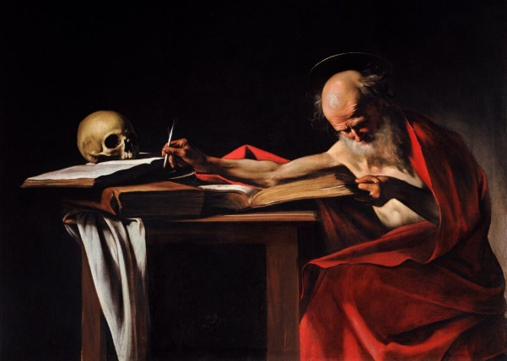 St Jerome Writing

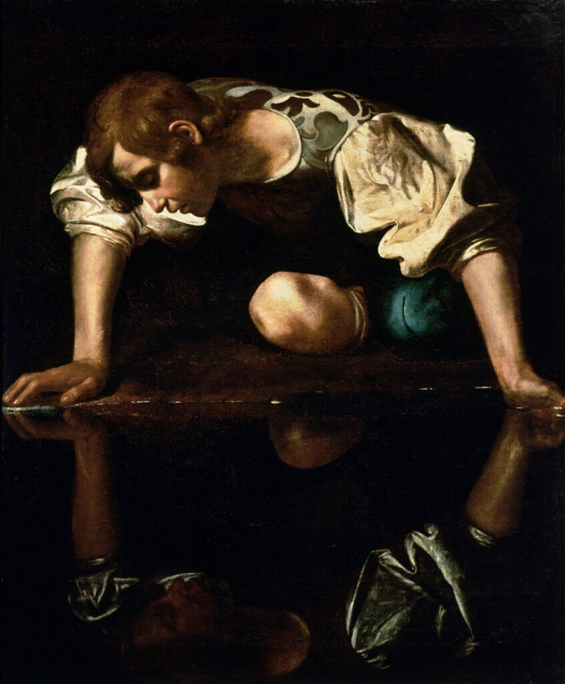Narcissus

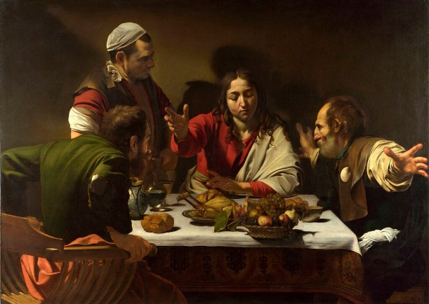The Supper at Emmaus

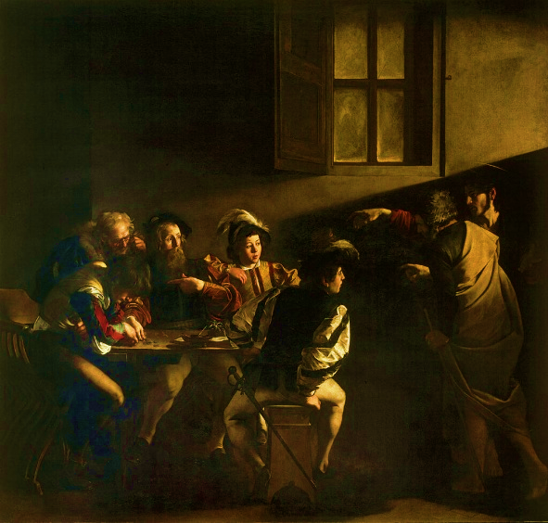 The Calling of Saint Matthew

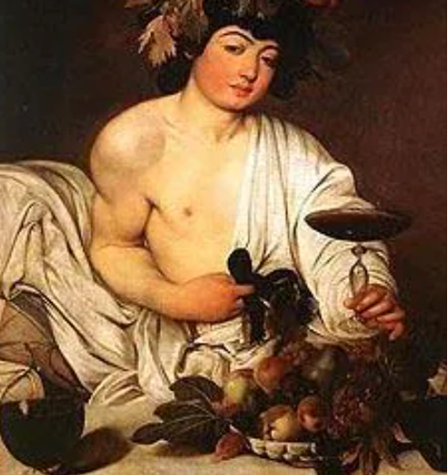
Fun fact
There’s a tiny detail on a carafe of wine in this picture of ‘Bachus’, which shows Caravaggio at work at his easel, painting this picture. Unfortunately over the years it has been lost to sight so it can only be seen using advanced scientific techniques.
