Katsushika Hokusai

🖌️ What did Hokusai create?
Katsushika Hokusai was a Japanese artist best known for his woodblock prints, paintings, and illustrations. His most famous artworks include landscapes, especially Mount Fuji, and powerful ocean waves with boats and sea creatures.

👶 Childhood
- He was born in 1760 in Edo, Japan (now Tokyo).
- His father was a mirror-maker for the shogun (military ruler).
- He started drawing around the age of 6.
- As a child, he was fascinated by nature and the sea.

📚 Education
- He became an apprentice to a wood-carver at age 14.
- He joined the Katsukawa art school, where he trained in ukiyo-e (pictures of the floating world).
- He studied styles from China, Japan, and even Europe.
- Hokusai often changed his name to mark new stages in his learning — he used over 30 names!

👨‍🎨 Career
- He worked as a printmaker, illustrator, and book artist for over 70 years.
- He created the famous "Thirty-Six Views of Mount Fuji" series.
- His work inspired Impressionist artists like Monet and Van Gogh.
- Even at age 89, he was still drawing and said he was just beginning to understand art!

💬 Quotes from Hokusai
"From the age of six, I had a mania for drawing the shapes of things."
"If I go on trying, I will surely understand them still better by the time I am ninety."

🖼️ Artworks
The Great Wave off Kanagawa (a series of paintings)
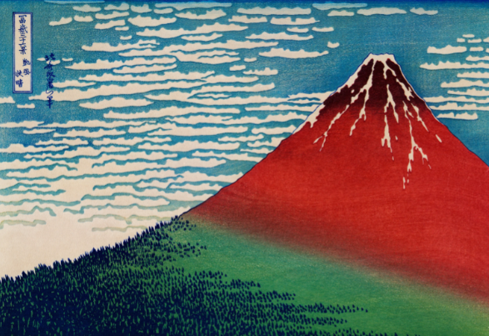
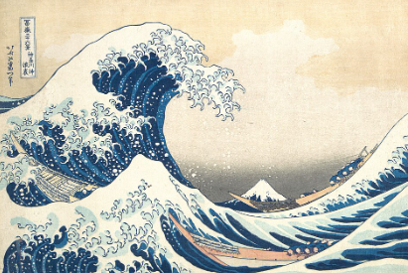
Fine Wind, Clear Morning (Red Fuji)

Yoro waterfall in Mino Province
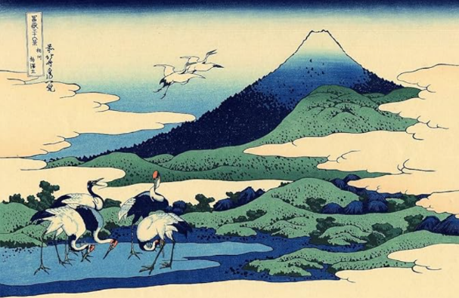
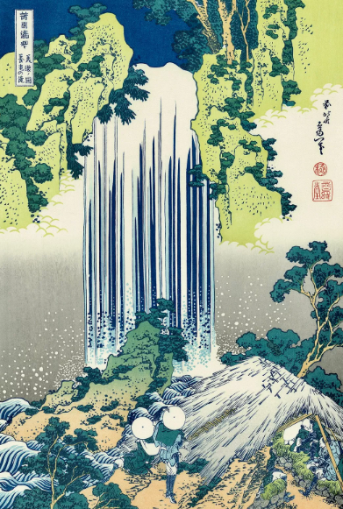

Cranes (series of paintings)

🎉 Fun Activities
- Try making your own wave artwork with swirling blue acrylic paint!
- Make a paper Mount Fuji collage using coloured paper.
- Create your own woodblock-style print with foam and paint.
- Learn Japanese numbers and write your age in Kanji characters!

Colouring page inspired by The Great Wave off Kanagawa

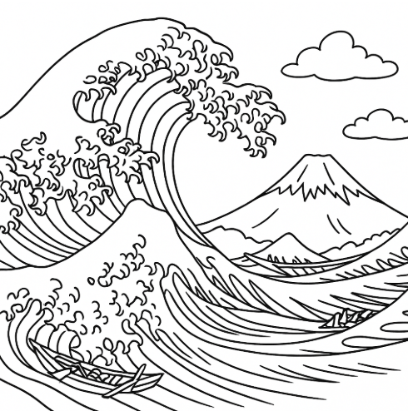

Colouring page inspired by Mount Fuji in Red

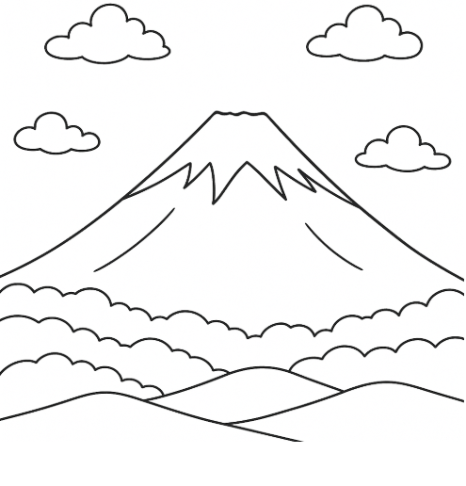

Colouring page inspired by Yoro Waterfall in Mino Province
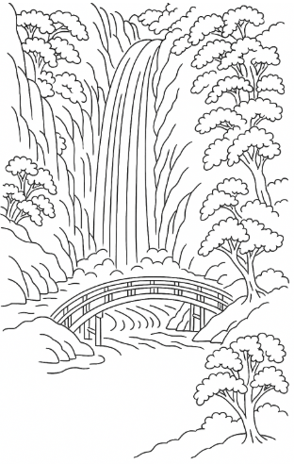

Colouring page inspired by Flying Cranes and Clouds
