**👶 Who Was Charley Harper?**

* **Name:** Charley Harper
* **Born:** **August 4, 1922**
* **Famous For:** Making bright, bold animal art using shapes like circles, triangles, and lines!

**🐞 What Did He Love to Draw?**

Charley loved animals most of all! His favourites were:

* 🐦 Birds
* 🐟 Fish
* 🐸 Frogs
* 🐞 Insects
* 🌸 Flowers
* 🌲 Trees and forests

He said nature was **funny, cute, and interesting** — and he wanted to show that in his art.

**🧒 Childhood Adventures**

Charley grew up on a **farm in West Virginia**.  
🌲 He loved **being outside**, watching animals and insects, and drawing what he saw.

Even as a kid, he liked to keep his drawings **simple and fun** — not too much detail!

**🎓 His Education**

📚 First, Charley went to **West Virginia Wesleyan College**.  
🎨 Then he studied art at the **Art Academy of Cincinnati**, where he learned how to paint and draw in his own creative way.

**👨‍🎨 His Art Career**

Charley Harper worked as a **professional artist** for many years!

🖼️ He made posters, magazine covers, book illustrations, and even art for nature parks.

Some fun facts about his career:

* He illustrated **The Golden Book of Biology**, a famous children’s science book 📘
* He made posters for the **U.S. National Parks** 🌳
* His art was used in nature centres and zoos all over the country
* He taught art at the **Art Academy of Cincinnati** (where he once studied!) 🎓
* He worked from home with his wife **Edie Harper** who was also an artist
* He created Harper Studios with Edie and son **Brett** Charley’s artwork became very popular because it was:

✔️ Bright  
✔️ Simple  
✔️ Full of animals and nature!

**🎨 What Was His Style Called?**

Charley called his art style **“minimal realism.”**

That means:

* He drew real things like animals...
* But he used **only basic shapes** to show them
* No tiny details — just the **most important parts**

He said:

“I don’t count feathers. I just count the wings. I see exciting shapes, colour combinations, patterns, textures, fascinating behaviour and endless possibilities for making interesting pictures.”

**🌟 His Most Famous Artwork**

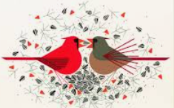Charley Harper made many amazing pieces, but here are a few that became especially **famous**:

**🐦 *“Red and Fed”***

Shows two bright red **cardinals** — one feeding the other a seed.

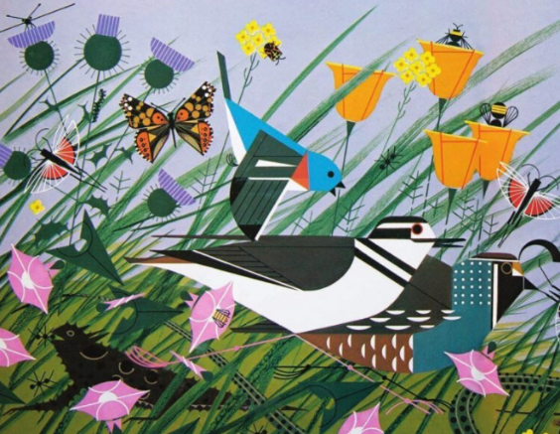A perfect example of **bold color and clean shapes**

**🌳 *“Once There Was a Field”***

A big piece with many tiny animals and birds hidden in a field of shapes.

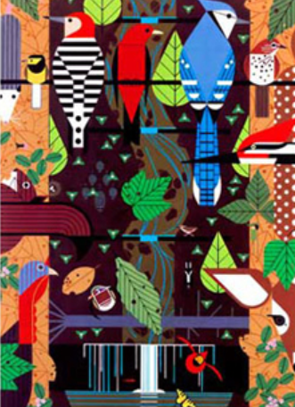It’s like a nature puzzle!

**🦉 *“Birducopia”***

A funny name (like "cornucopia") — it shows **a bunch of different birds** all together in one place, perched and peeking out!

These artworks are famous because they’re **beautiful, fun, and full of character**, even though they use only simple shapes and colours.

He created many illustrations, such as these for the Giant Golden Book of Biology:

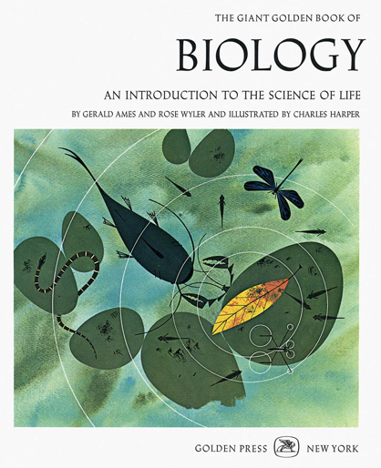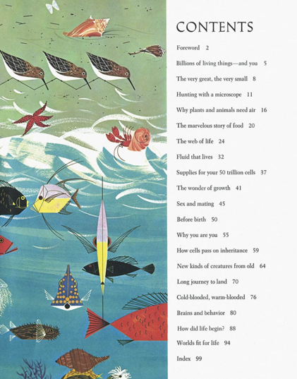

Ecosystems: Woodland forest 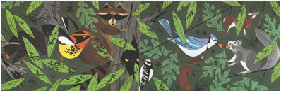

Prairie soil 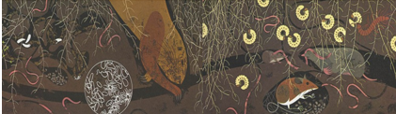

The desert at night 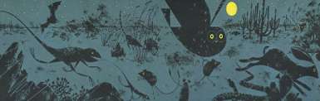

Famous people and their work, such as Gregor Mendel

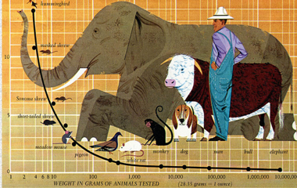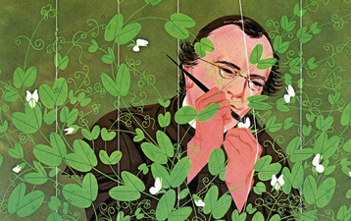

& Scientific theories and facts, such as Oxygen requirements v weight

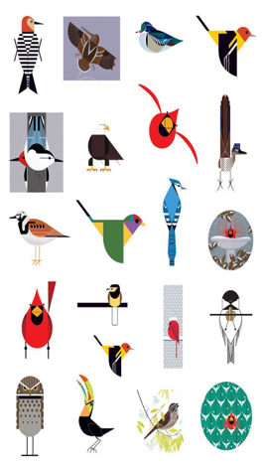

He is best known for his illustrations of birds

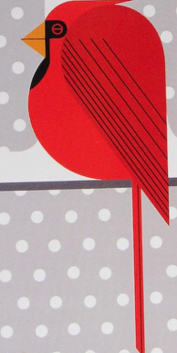**✏️ Make Your Own Charley Harper Art!**

1. Think about a bird
2. What is the basic shape of your bird? Is it large, thin, pointy, tall, small?
3. If you broke your birds body type into basic shapes what would they be?
4. Draw those basic shapes: an oval body, a triangle wing, a little round head?
5. Does it have any prominent features? A large tail, round body, pointy head? What shape would they be? Add them
6. A couple of owls with eggs on a green background

   AI-generated content may be incorrect.Is it famous for anything? For example: robins have large red tummies, peacocks have long flowing tales, owls have large round eyes, accentuate these features.
7. What is the birds personality? Is it grumpy, angry, clever?   
   How will you show that? frown lines? grumpy eyebrows? evil eyes?

1. Add colour, big blocks of colour, with stripes, and spots to differentiate features and parts of the bird
2. Include a background – somewhere you would normally find this bird – a tree? a forest? a beach?

Or, you can make a collage with paper shapes!

