Paul Cézanne was born on January 19, 1839, in Aix-en-Provence, France.

As a child, he loved to explore the countryside, climbing hills and looking at nature. He later painted these beautiful landscapes in his famous artwork! He even painted pictures of his favourite mountain, Mont Sainte-Victoire, over 80 times! 🏔️

He loved painting things like mountains, fruit, and people, but didn’t paint them to look exactly like a photograph. Instead, he used shapes like cubes, cylinders, and patches of colour to build his pictures—like a puzzle!

**Cézanne’s Education**

📚 Early Schooling (1849-1858)

* Paul went to the Collège Bourbon (now called Lycée Mignet) in Aix-en-Provence.
* He was really good at math and Latin, but he loved drawing the most!

⚖️ Law School (1858-1861)

* Paul’s father wanted him to become a lawyer, so he went to Aix-en-Provence Law School while also taking art classes.
* Even though he was a good student, he didn’t love law. His heart was in painting!

🎨 Art School in Paris (1861)

* Paul finally convinced his father to let him go to Paris to study art.
* He tried to get into the École des Beaux-Arts, a famous art school, but he was rejected!
* Instead, he studied on his own at the Académie Suisse, where he met other young artists like Camille Pissarro.

**Cézanne’s Early Jobs**

💰 Worked at His Father’s Bank (1860-1861)

* His father owned a bank, and Paul worked there for a short time.
* He didn’t like the job because he wanted to be an artist, not a banker!
* He kept drawing and painting whenever he could.
* Cézanne’s father eventually accepted his love for painting and even supported him with money so Paul could focus on his art!
* Even though Cézanne had to try law and banking, he never gave up on his dream of being an artist.

**Why Was He Special?**

* He painted the same things over and over to find the best way to show them.
* His brushstrokes looked like tiny building blocks of colour.
* He loved nature and painted lots of trees, hills, and his favourite mountain, Mont Sainte-Victoire!
* He helped inspire artists who later created Cubism including Picasso and Matisse.
* Today, he is known as the “Father of Modern Art” because his unique style inspired so many painters!

**His Artwork**

This is a self portrait of Cézanne, who created many beautiful paintings that changed the way people thought about art. Here are some of his most famous works:

🏔️ 1. Mont Sainte-Victoire Series (1880s–1906)

* Cézanne painted this mountain over 80 times!
* He used shapes and colours to show how the light changed on the mountain.

## 🍊 2. Turning Road at Montgeroult(1898)

* A painting of a village

  AI-generated content may be incorrect.Cézanne roamed the countryside looking for interesting viewpoints
* Shows how Cézanne played with perspective and space in his paintings.

🍏3. The Basket of Apples (1893)

* A painting of a bowl of fruit and a bottle of cookies

  AI-generated content may be incorrect.A still-life painting of apples, a bottle, and a basket.
* He painted the table at different angles, making it look a little wobbly on purpose!

**Fun Fact!**

Cézanne once said, “With an apple, I will astonish Paris.” He meant that even simple things, like fruit, could be painted in amazing new ways! 🍏

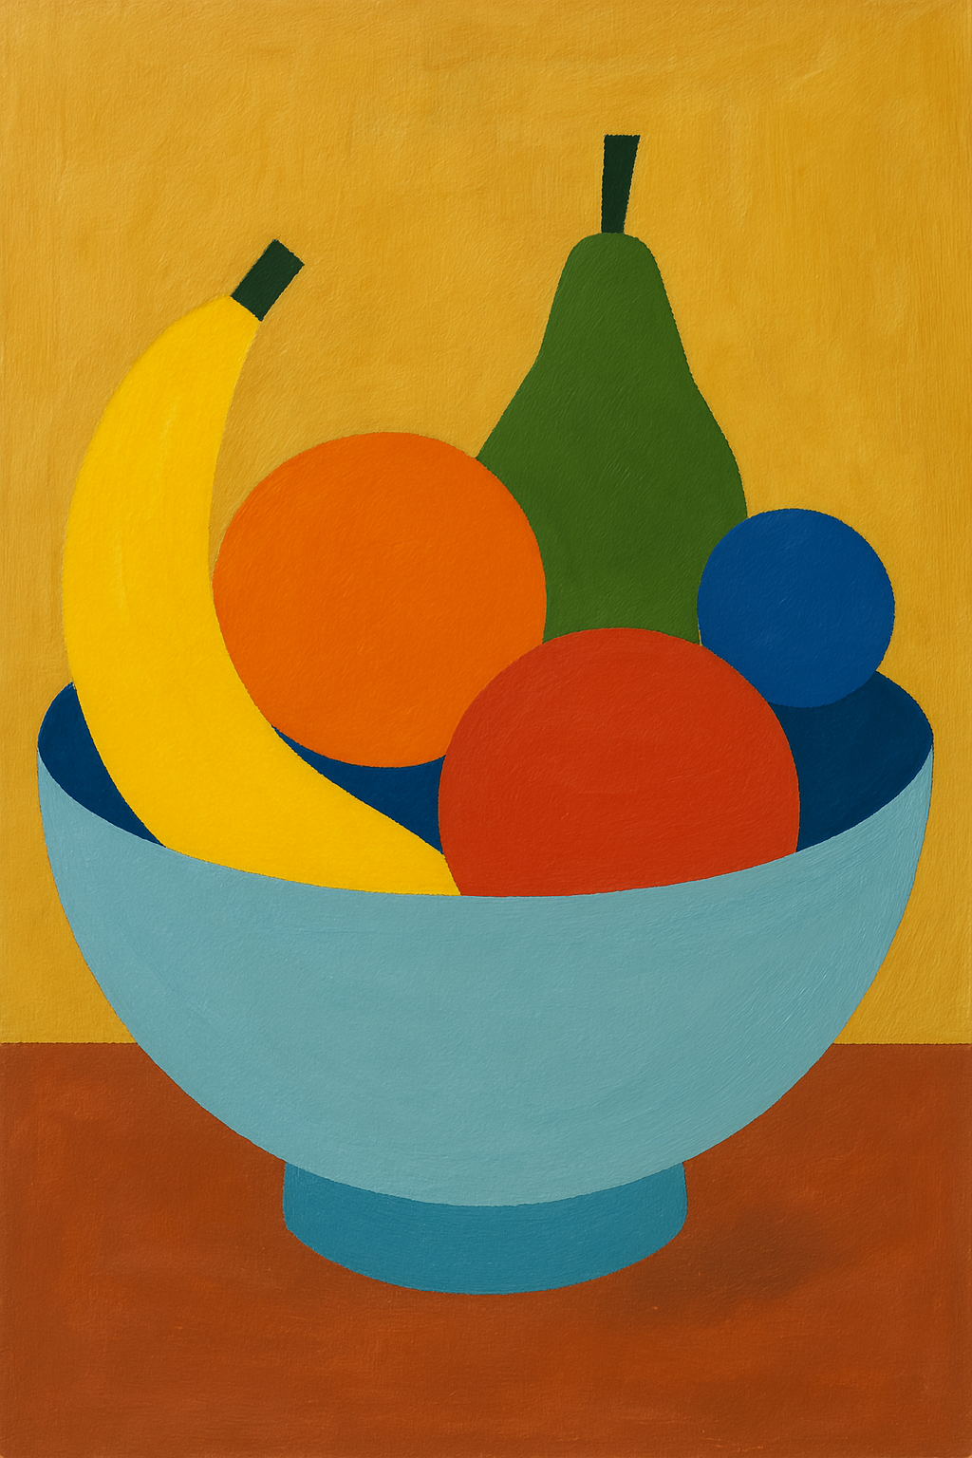**Would you like to try painting like Cézanne?**

Grab some paper and colors and paint a bowl of fruit using only shapes! 🍏🍊🍌

Try drawing a tree using only circles, squares, and triangles! 🌳 🎨

Try drawing a mountain using only shapes like circles, squares, and triangles! 🌳 🏔️

Take and print a photograph of something. Paint over this print, with bright colours and strong brushstrokes.

Print and colour the following Cezanne inspired colouring pages



