🧒 Who Was Barbara Hepworth?
Barbara Hepworth was a famous British artist and sculptor. She made beautiful sculptures out of stone, wood, and metal. Her art is often smooth and curvy — and sometimes has big holes right in the middle!
Barbara Hepworth was one of the first women to become a world-famous sculptor — at a time when most artists were men!

👧 Childhood Facts
- Barbara was born on January 10, 1903 in Wakefield, West Yorkshire, England.
- She loved drawing and music as a child.
- She enjoyed being outdoors and loved looking at the shapes in nature.
- Her father was an engineer, and she often went with him on car rides to look at the countryside.

🎓 Education Facts
- Barbara was very clever and went to Wakefield Girls’ High School.
- She studied art at the Leeds School of Art.
- One of her classmates was Henry Moore, who also became a famous sculptor!
- She went on to study at the Royal College of Art in London.

🌳 Cool Facts
- Barbara’s sculptures are inspired by nature – the sea, sky, and landscapes.
- She wanted people to touch, walk around, and feel her sculptures.
- Barbara wanted to show the inside and outside of the sculpture, which is why they often have holes through them
- Her work is displayed in parks and galleries all around the world.

🗿 Her Amazing Sculptures
Here are some of her most famous works:
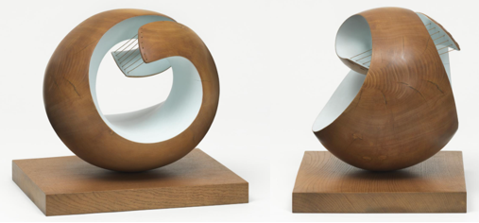
Pelagos (1946) – A smooth, spiral-shaped sculpture made of wood and string. It looks like waves or a shell.

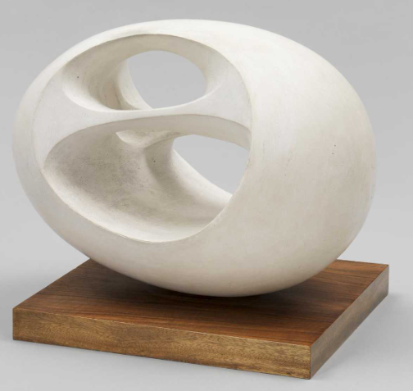
Oval Sculpture" (No. 2) (1943)
From a series of white sculptures with big holes in the middle.

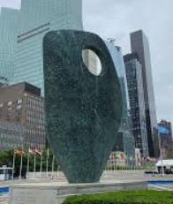
Single Form" (1961–64) – A huge bronze sculpture that stands outside the United Nations building in New York!

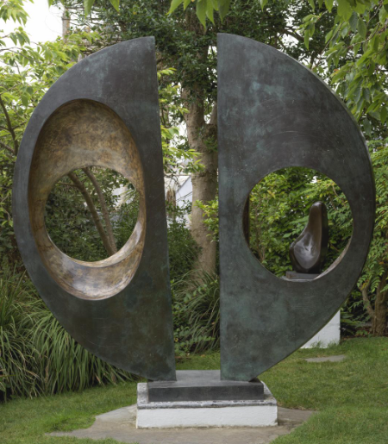

Two Forms" (1969) – Two smooth shapes that look like they’re having a conversation.

🌿 Barbara Hepworth’s Sculpture Garden
- Barbara Hepworth lived and worked in St Ives, Cornwall.
- Her home and studio are now the Barbara Hepworth Museum and Sculpture Garden.
- You can walk through the garden and see her real sculptures in the open air, just as she wanted them to be seen!
- The garden is full of trees, flowers, and peaceful corners — it feels like nature and art are working together.
- You can also see her workshop with her tools, and even see where she carved and polished her artwork.

🖍️ Activity – Be Inspired by Barbara and design your own sculpture

💡Start by thinking about it – think….
- What shapes do you see in nature? Think about nature: shells, waves, rocks, or trees.
- Where would you put your sculpture? How would you feel walking through Barbara Hepworth’s sculpture garden, and if you could put your sculpture in a garden, what would be around it?
- Barbara liked simple shapes, curves, and holes in her artwork. What shapes curves and holes would you add, and why?
🌀 Draw your own sculpture!
🎉 Bonus Idea: Create a mini sculpture using clay, playdough, or cardboard. Can you make a hole in it, like Barbara did?

